Contents
No table of contents entries found.

Sprint 2 Progress

Docker Compose build:

All services are built successfully:
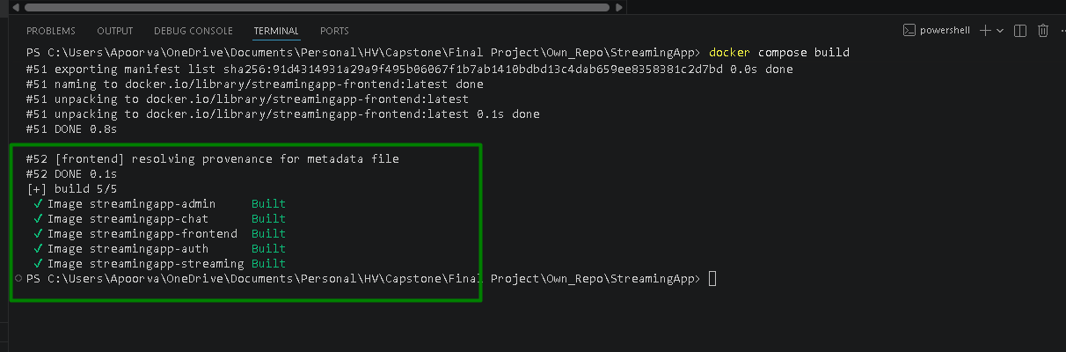

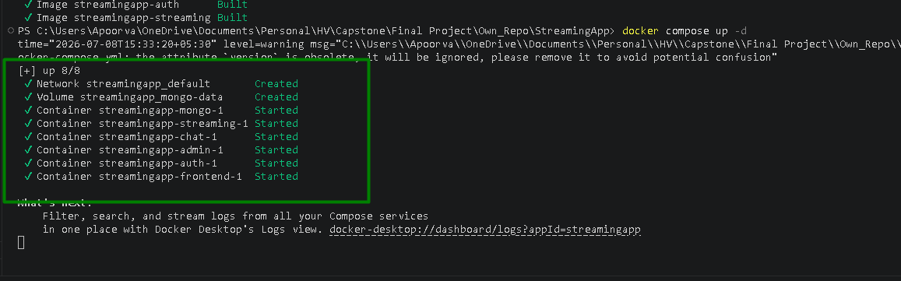
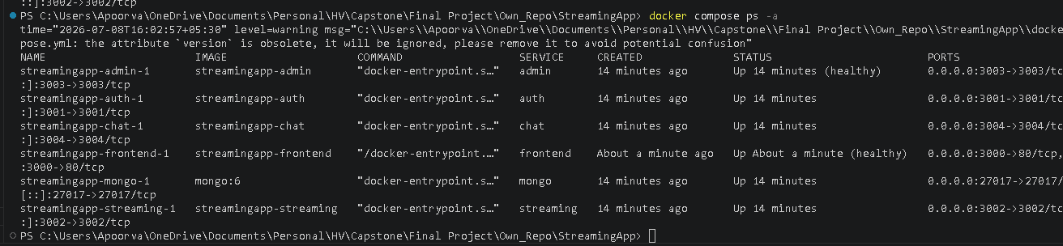

Kubernetes manifests: validated against real cluster with zero schema errors

Creating cluster:
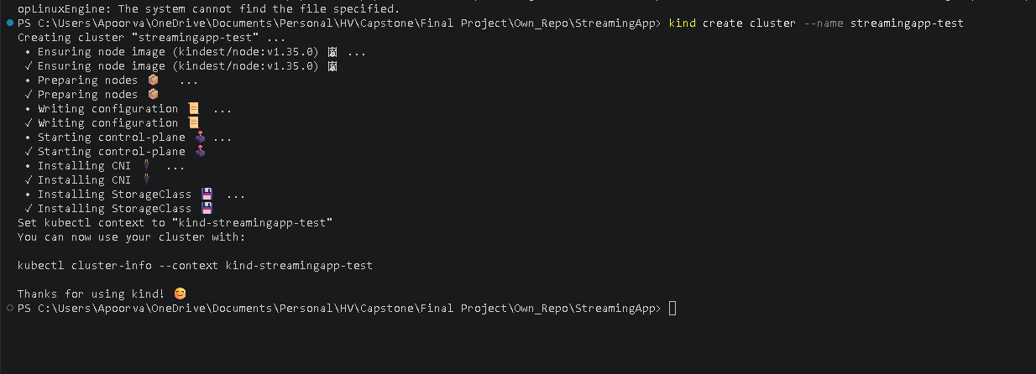
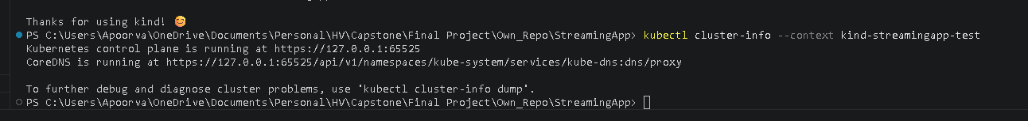
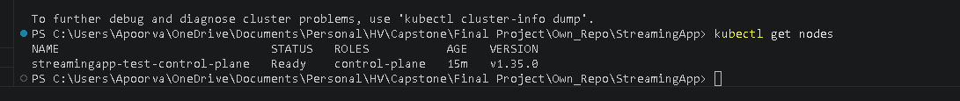
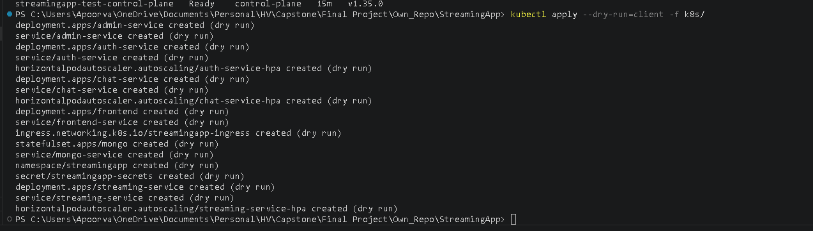
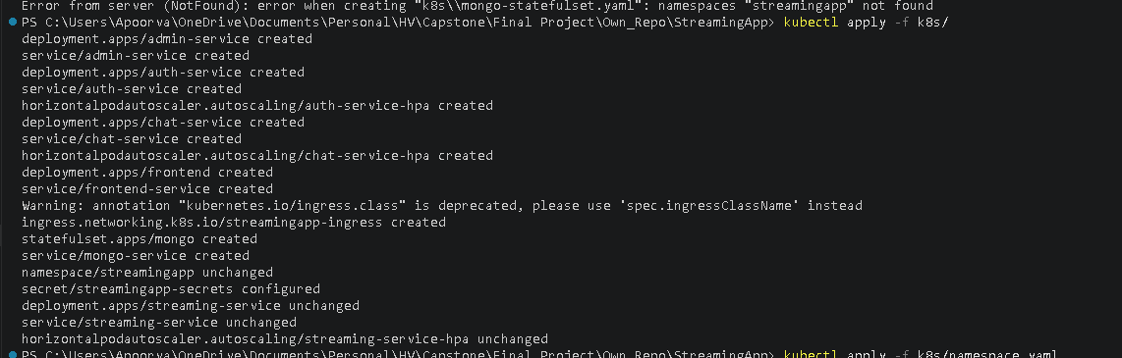

Helm chart — parses, renders, and produces valid Deployments/Services/HPAs
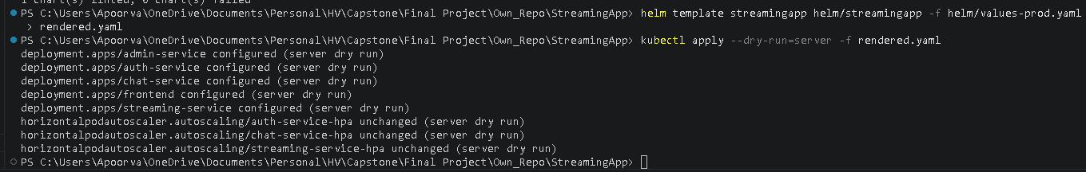
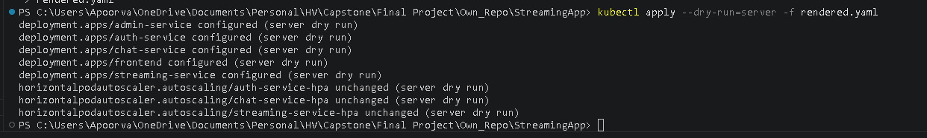
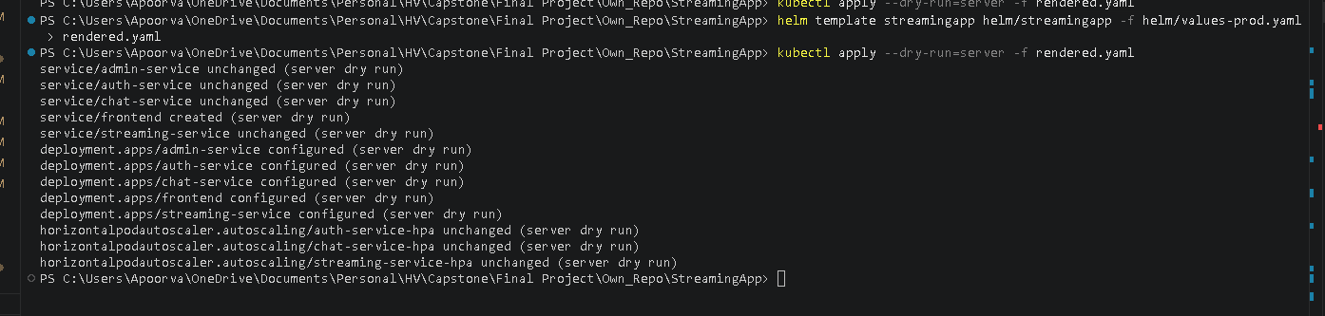

Terraform — VPC, EKS cluster (ACTIVE, v1.33, 2 nodes Ready), ECR, S3, IAM, security groups, Jenkins EC2 all provisioned and verified on real AWS

Terraform init:
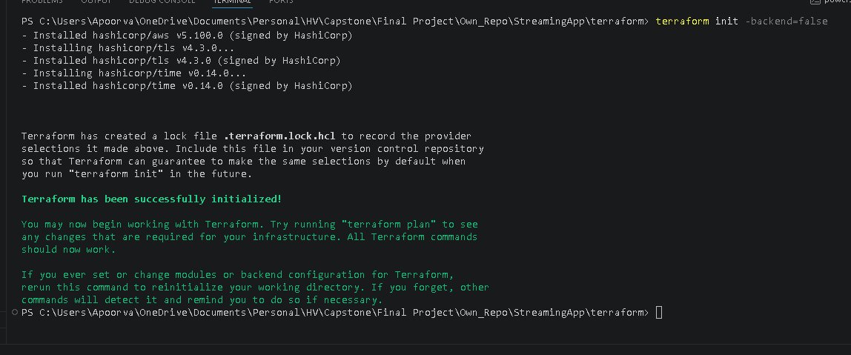

Created IAM user:
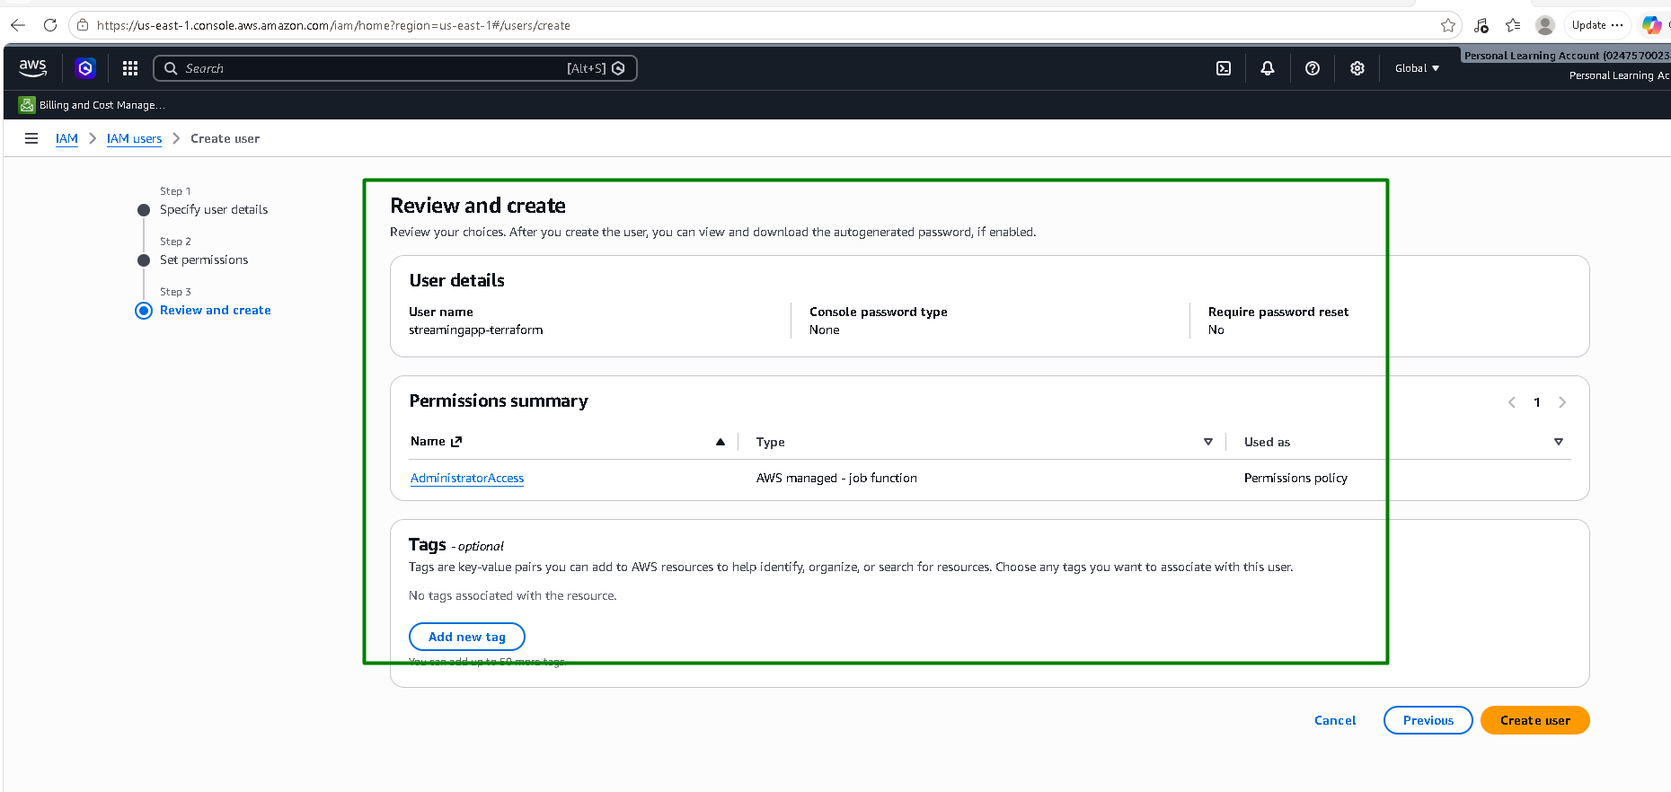

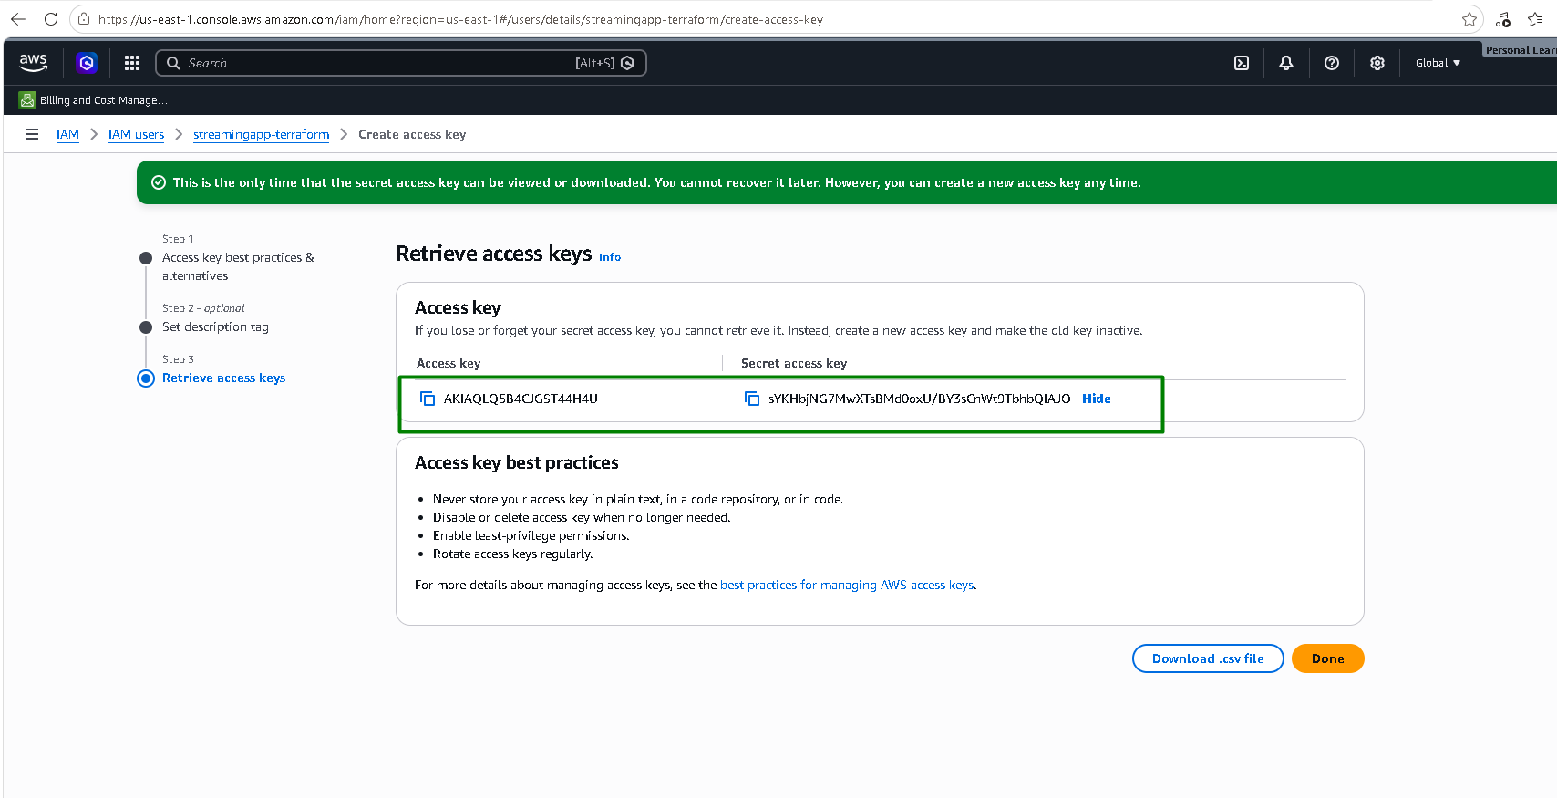

AWS CLI is configured:
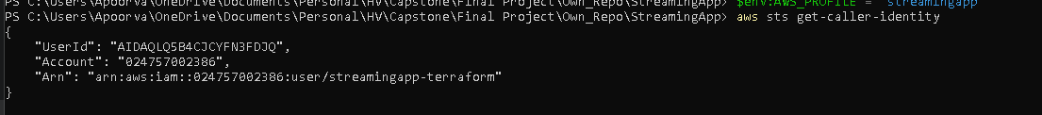

S3 bucket and DynamoDb table is created before applying Terraform scripts for below reasons:
S3 bucket (streamingapp-tfstate) — this is where Terraform stores its state file: a JSON record of every resource it manages and their current attributes, used to compute diffs on every plan/apply. Our terraform/main.tf backend block tells Terraform "store state remotely in this bucket" instead of a local terraform.tfstate file. But Terraform's S3 backend doesn't create its own storage — the bucket has to already exist before terraform init can point at it. If Terraform tried to create that bucket as part of the same run whose state it's supposed to be tracking in that bucket, we'd have a chicken-and-egg problem: it can't write its own state to a bucket while also treating that bucket's creation as something tracked in the state being written. So, the bucket has to be bootstrapped separately, outside the main config.
DynamoDB table (streamingapp-tflock) — this exists purely for state locking. Before any command that would modify state (apply, sometimes plan), Terraform writes a lock record into this table. If a lock is already present (say, from another terraform apply still running, or one you forgot you left mid-flight), the new command refuses to proceed instead of racing against it. Without this, two concurrent applies could corrupt the state file — e.g., both reading the same "current state," both computing different changes, and both writing back, with the second write silently clobbering the first's changes.

Create S3 bucket:

Create dynamodb table:
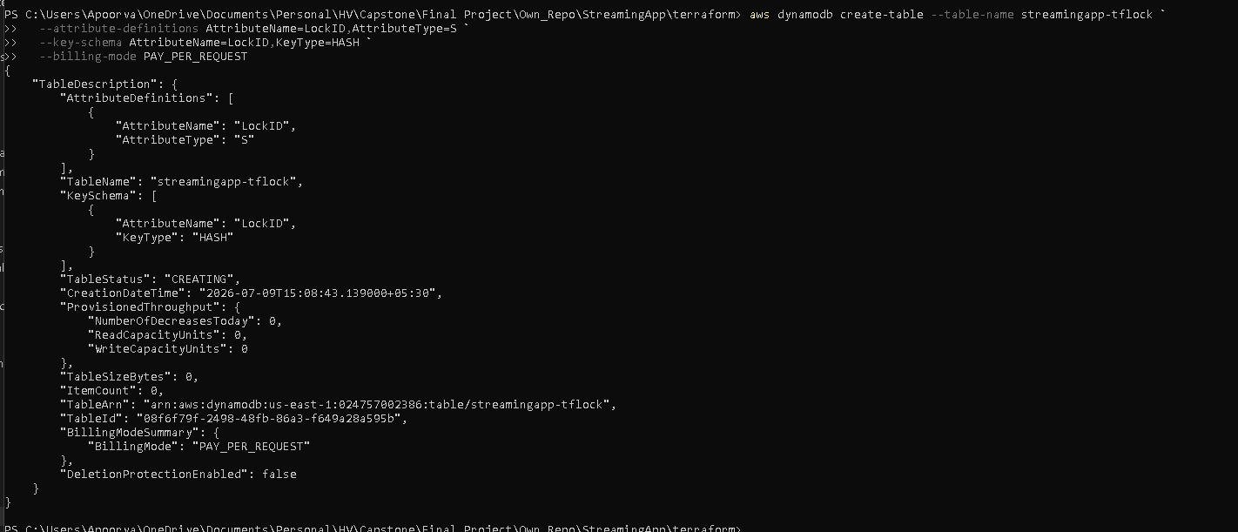

Run Terraform init again:
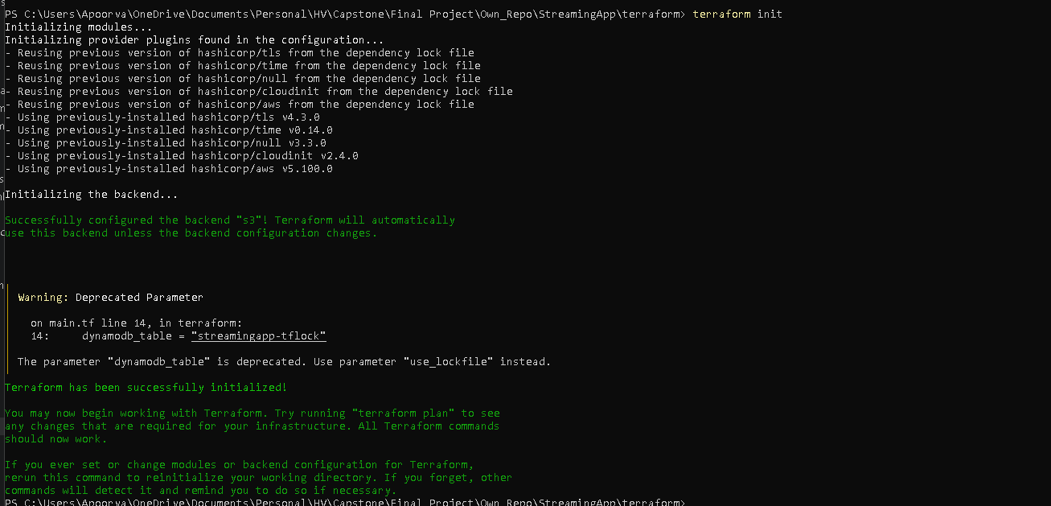

Terraform plan:
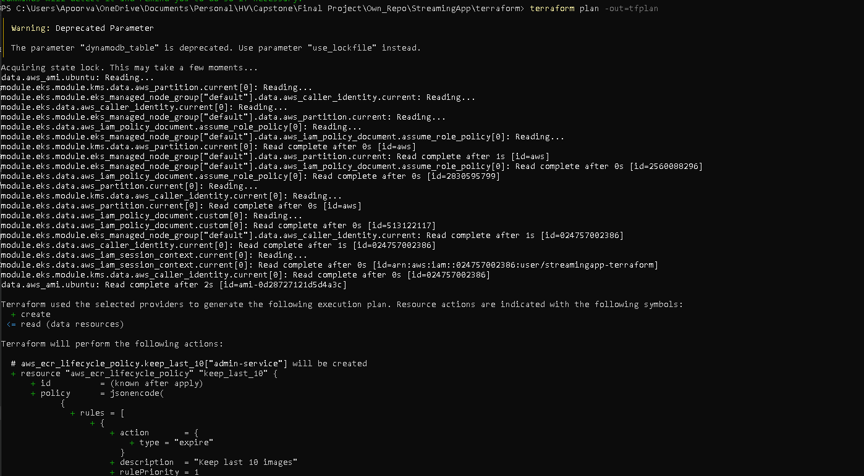
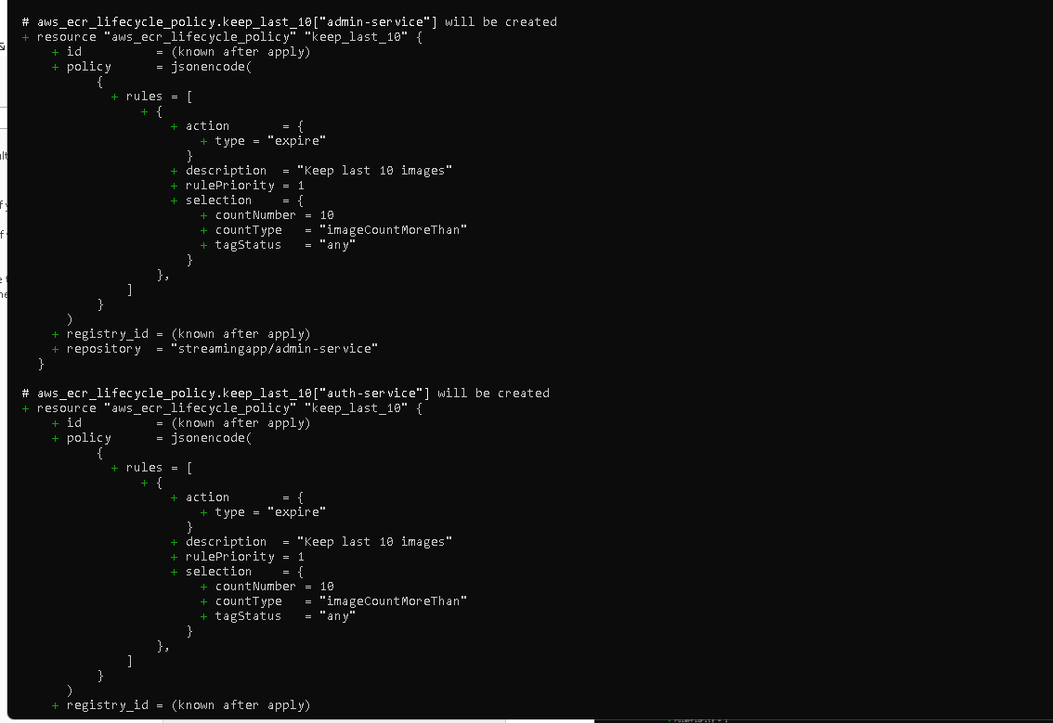
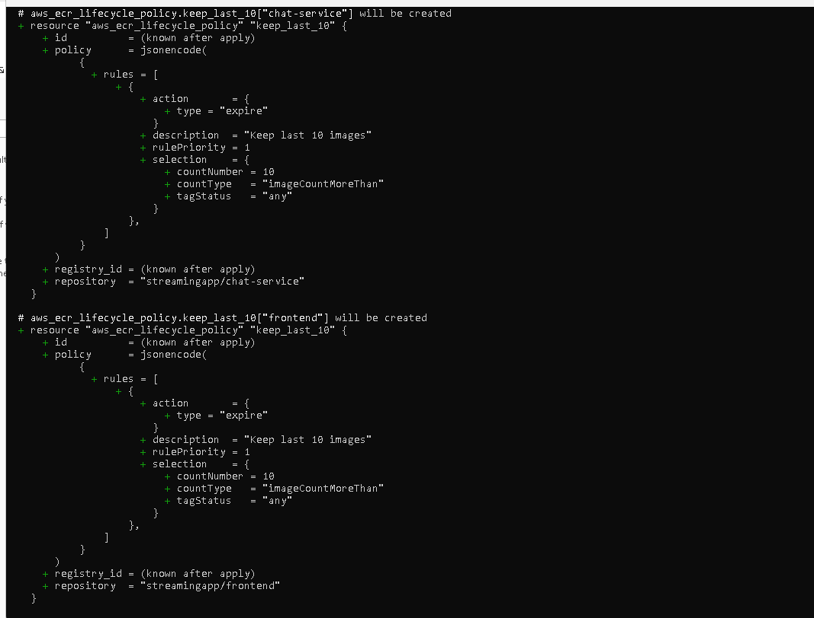
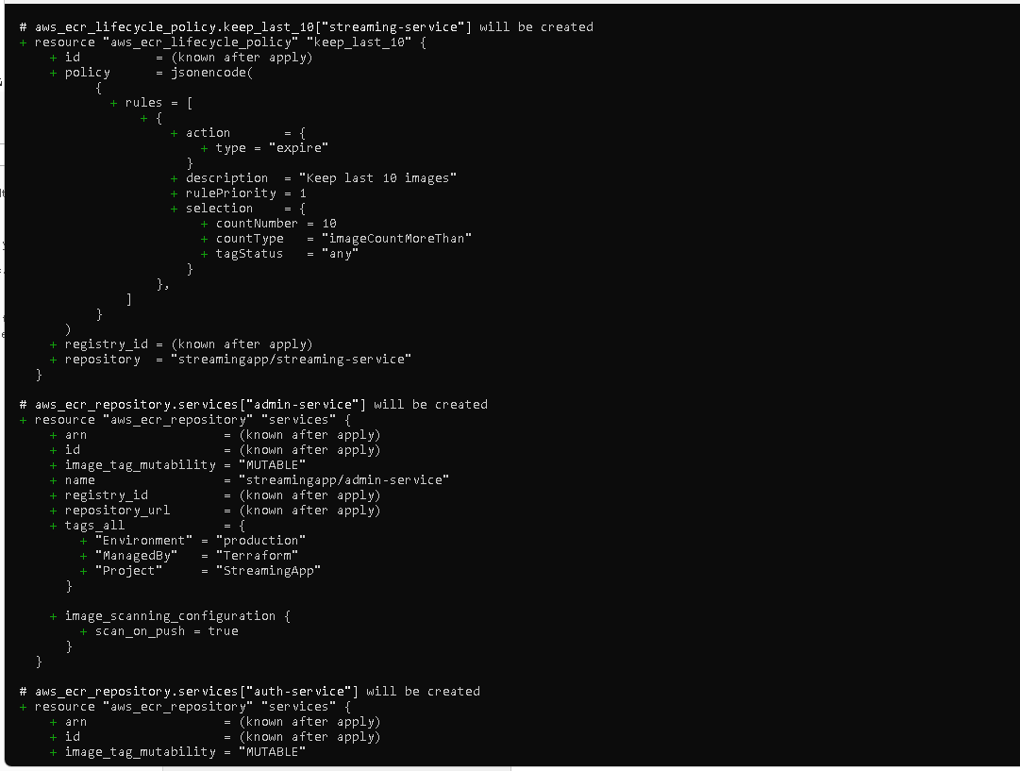
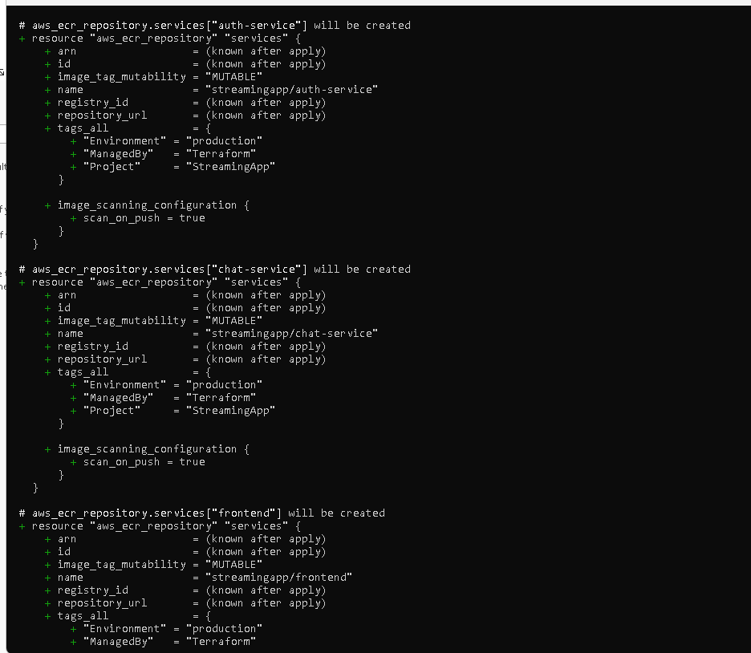
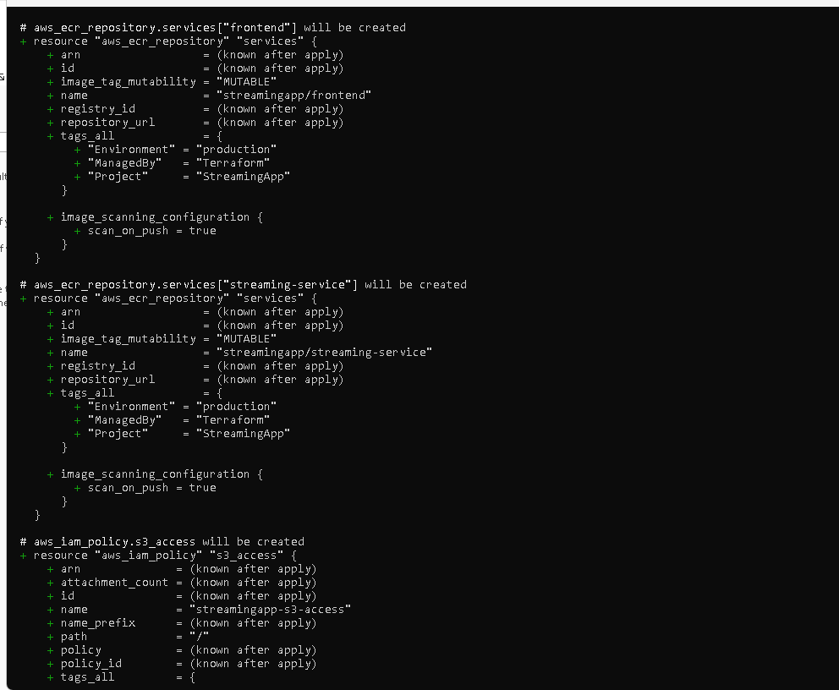
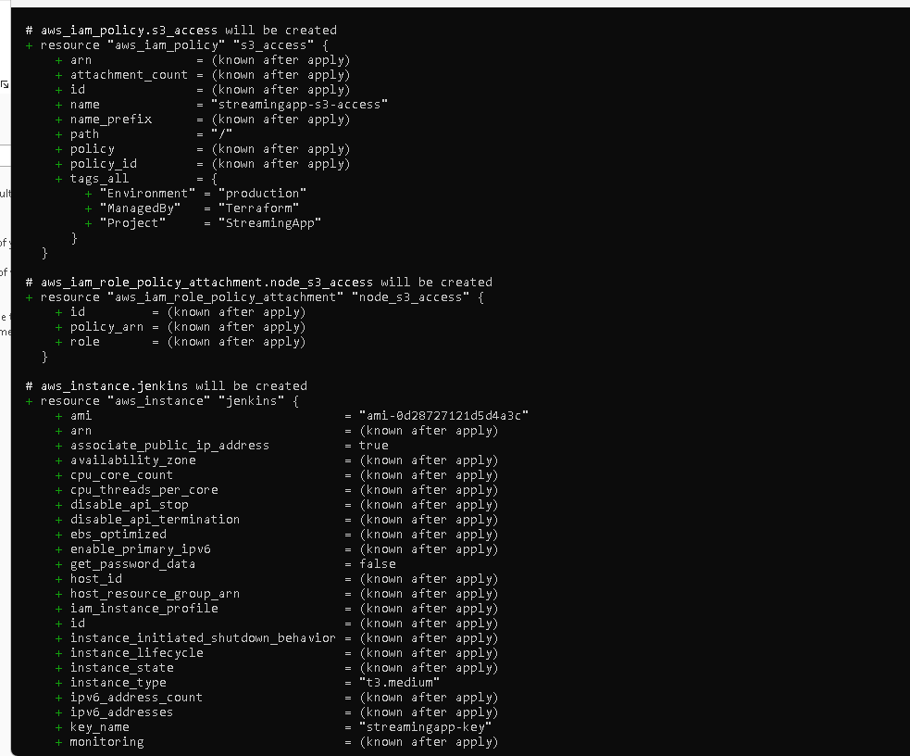
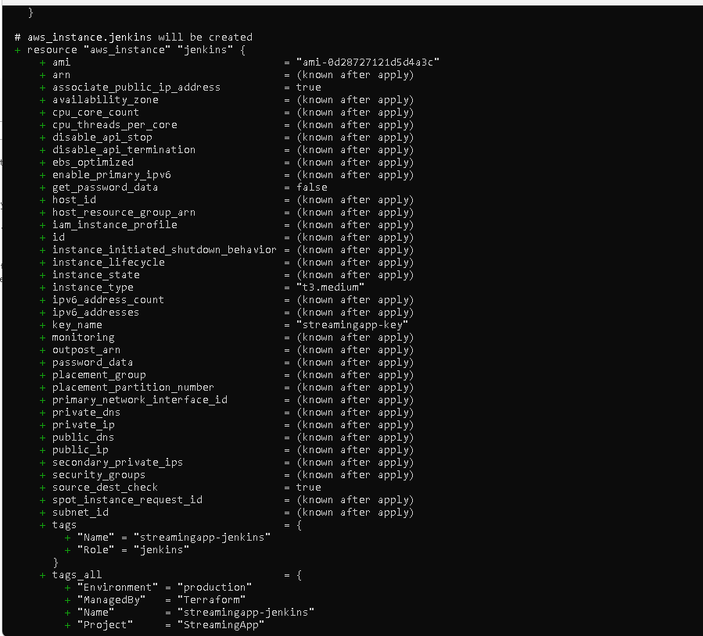
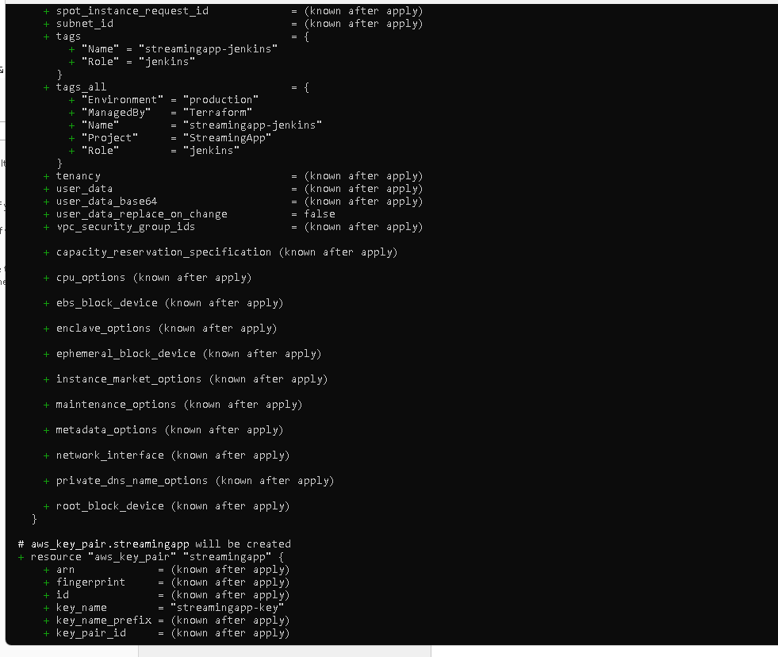
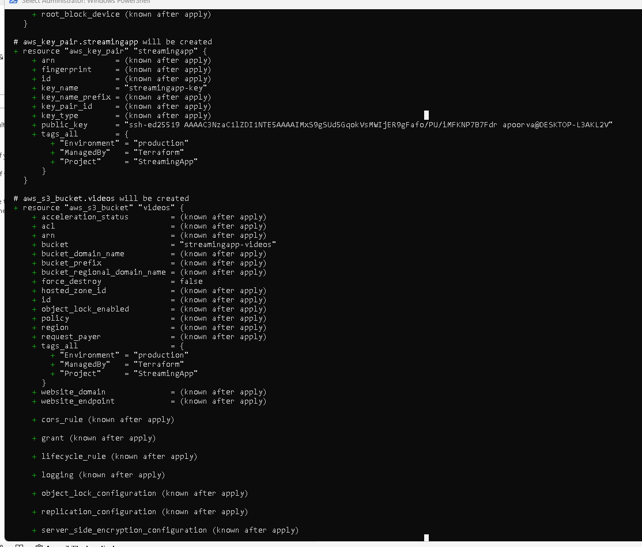
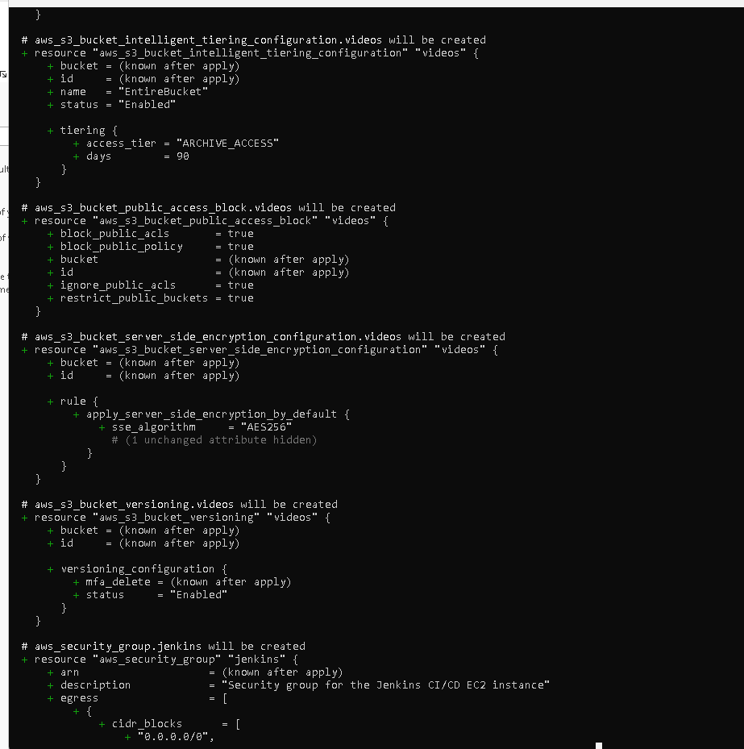
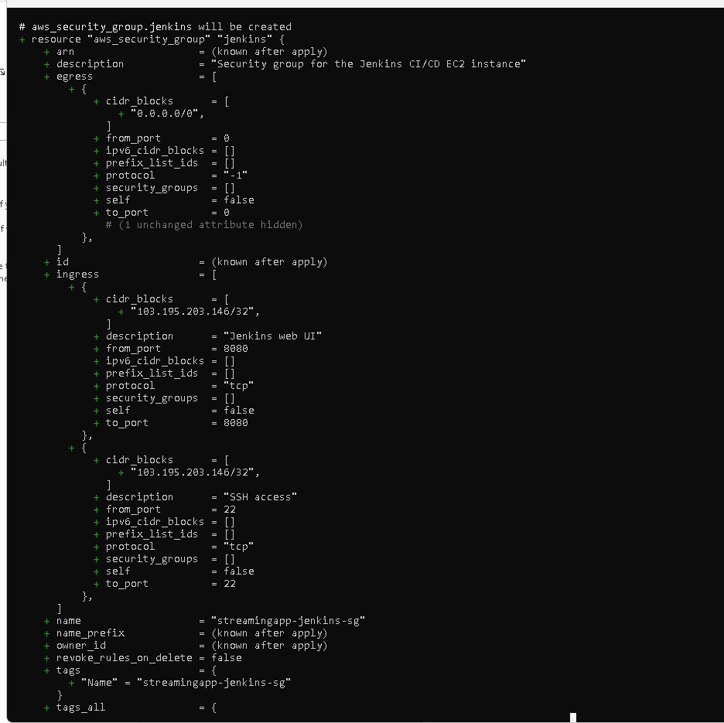
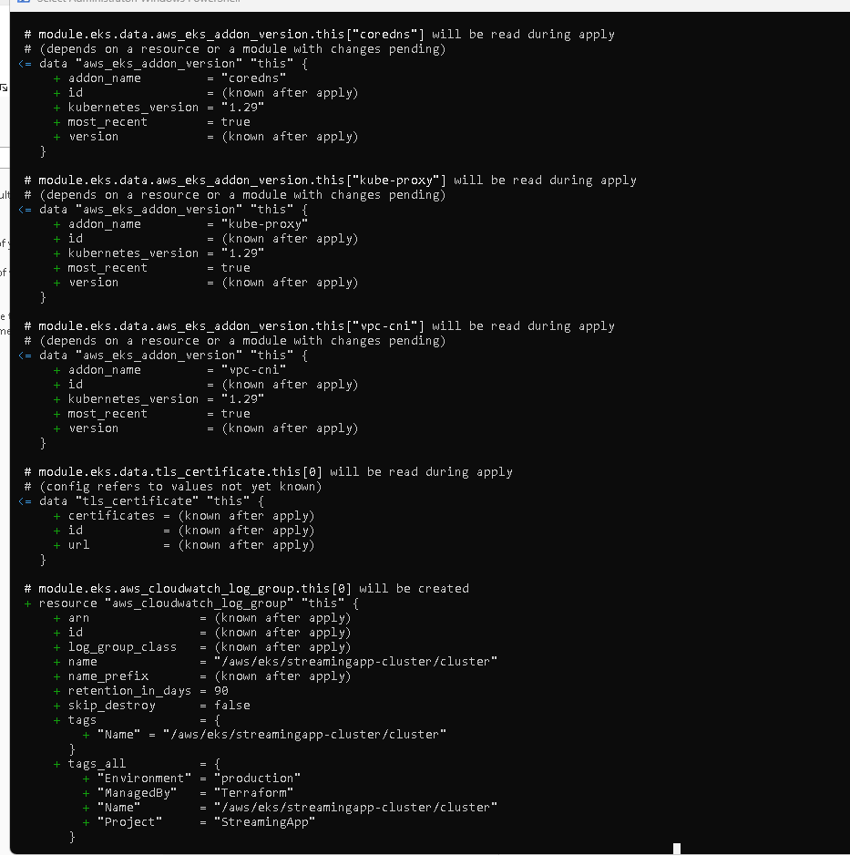
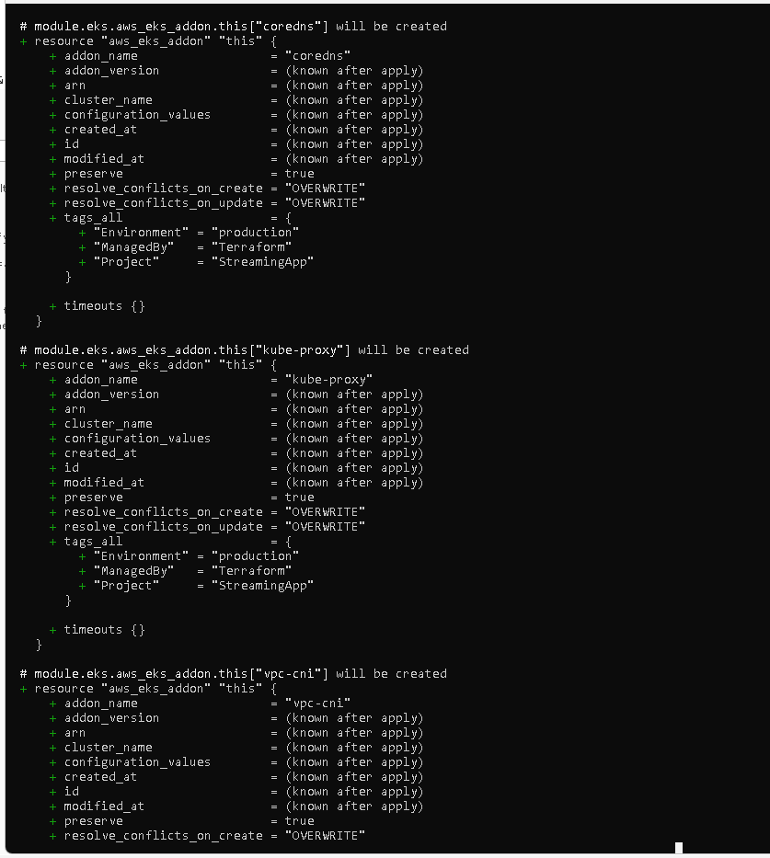
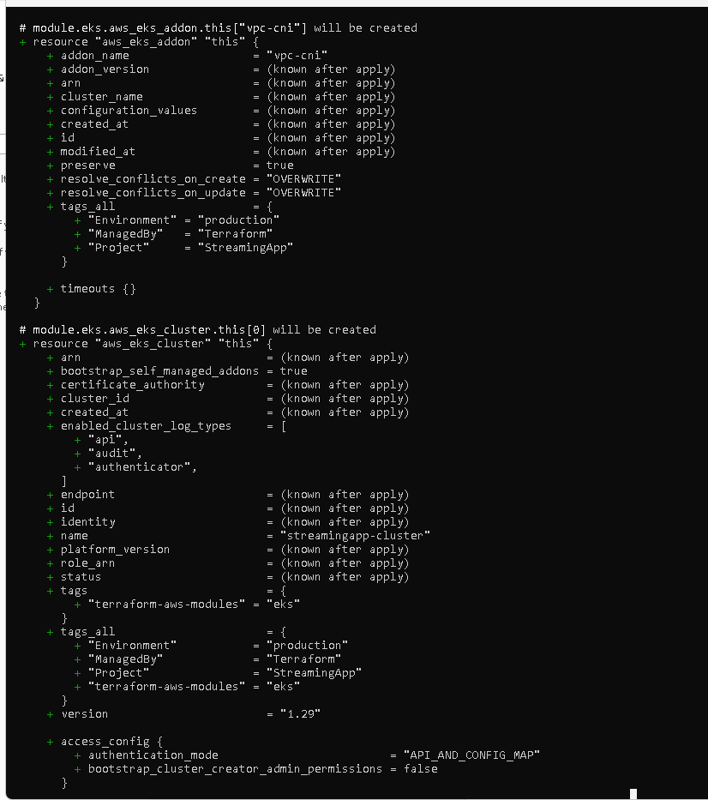
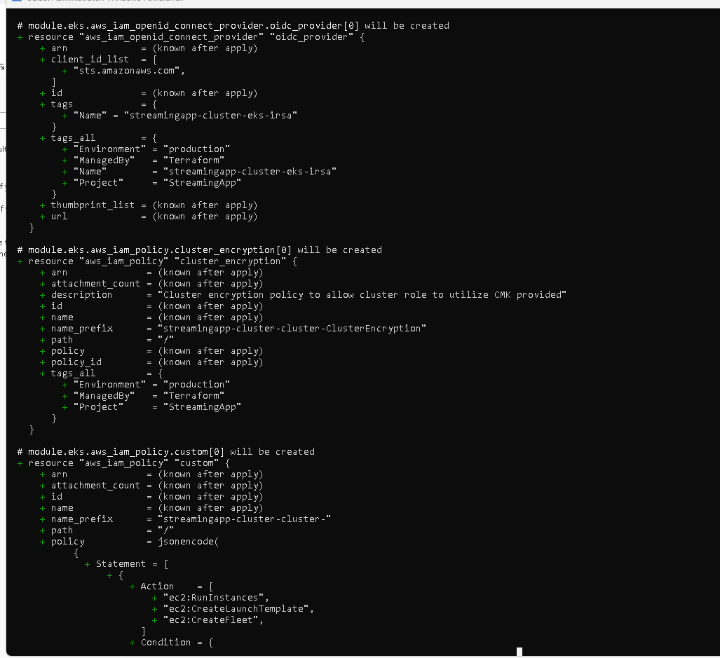
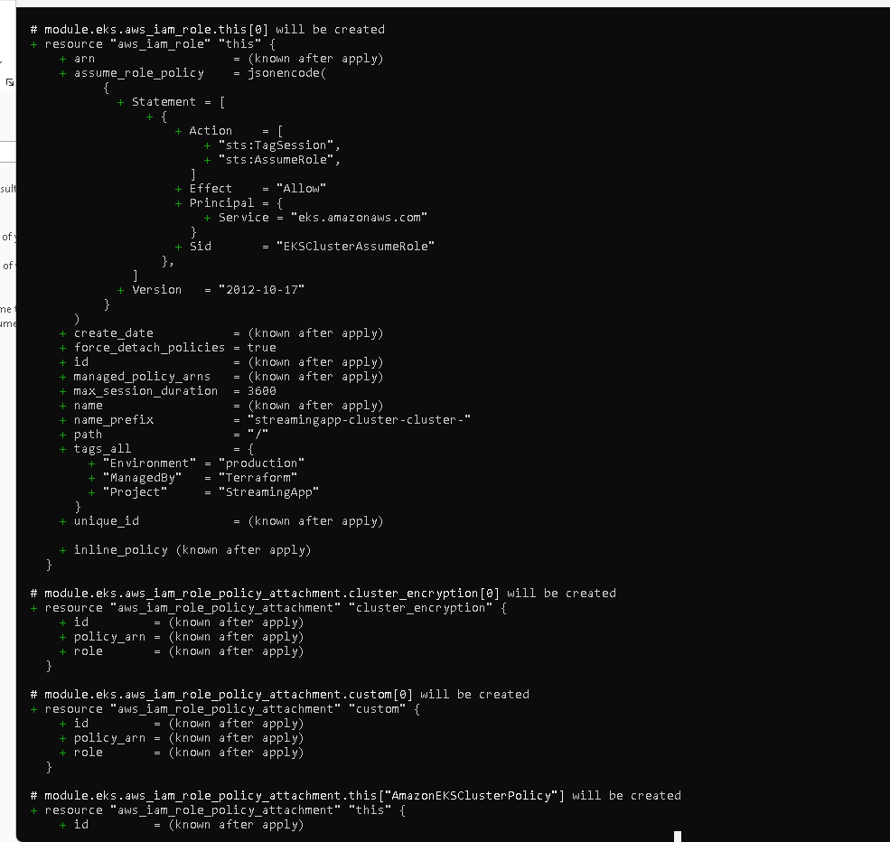
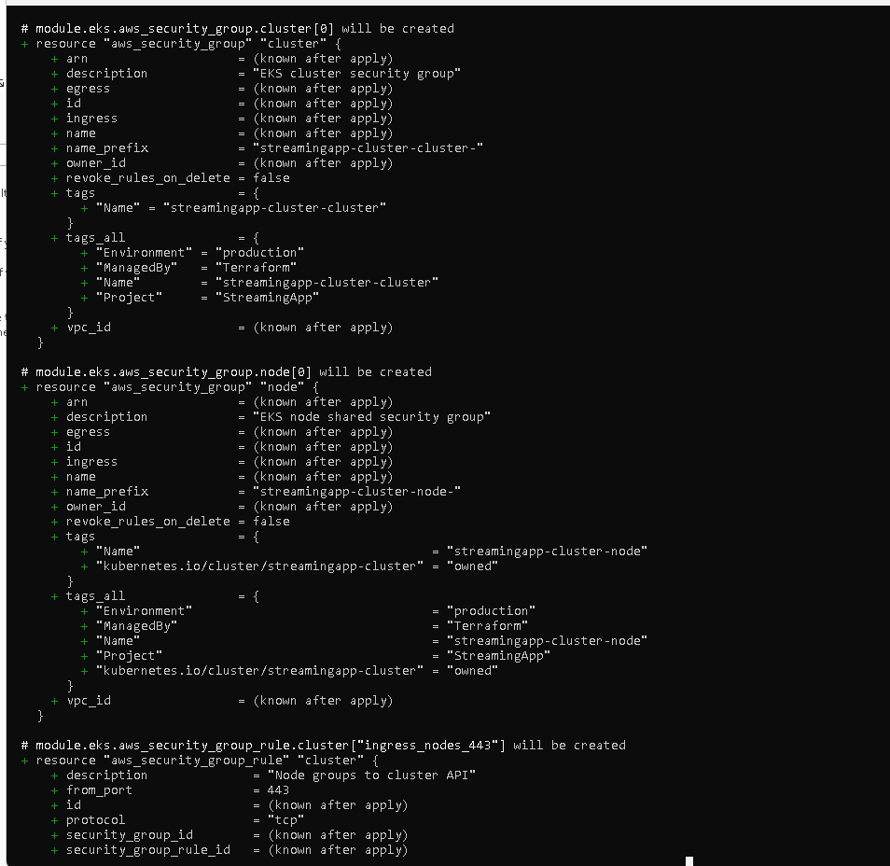
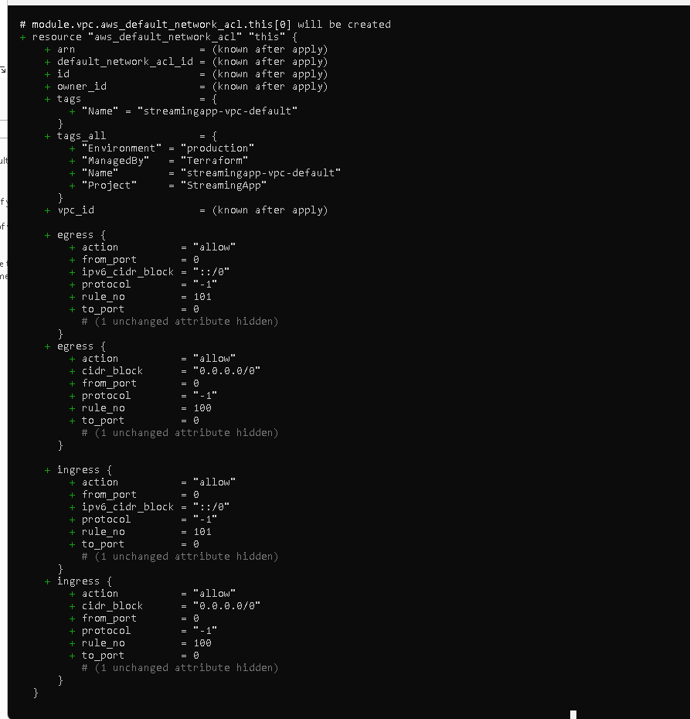
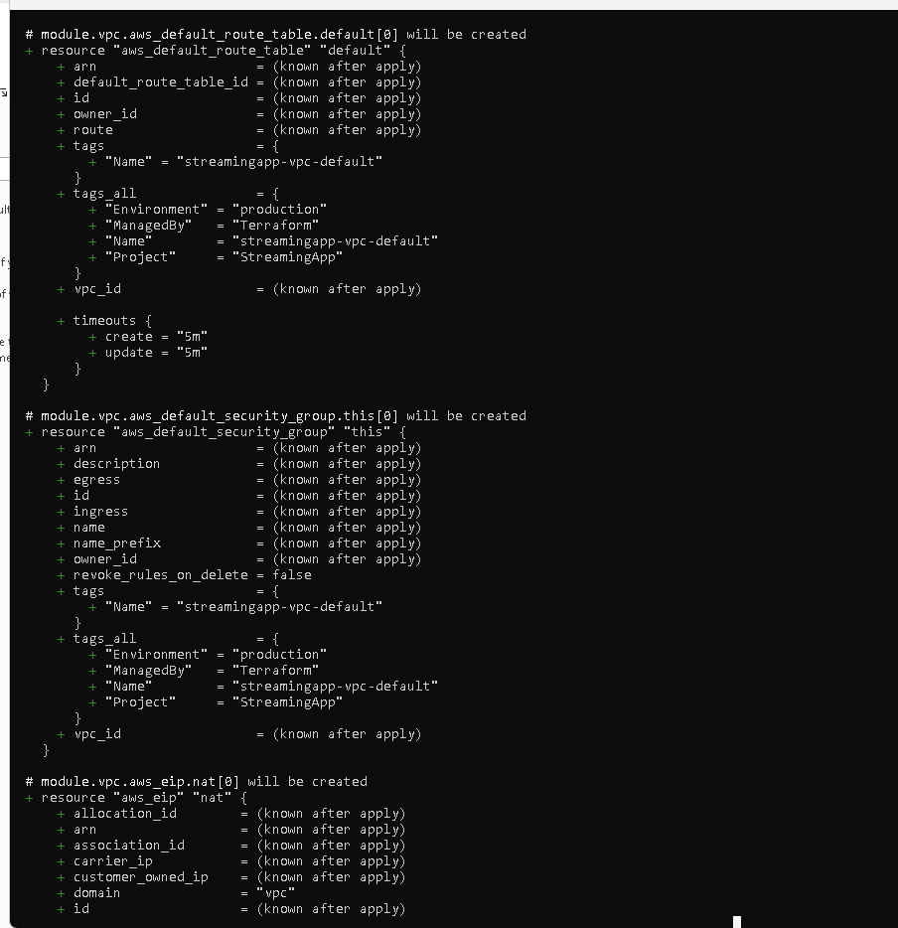
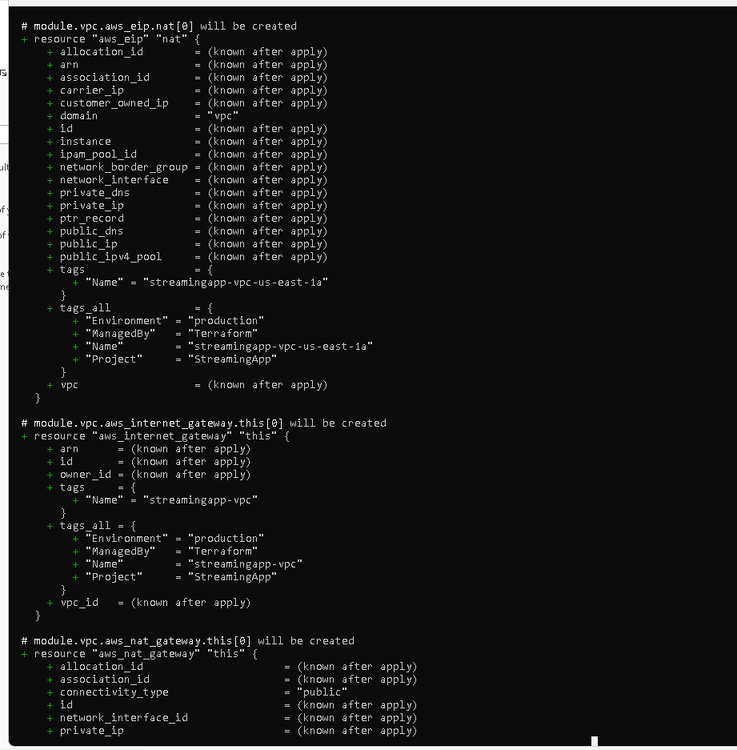
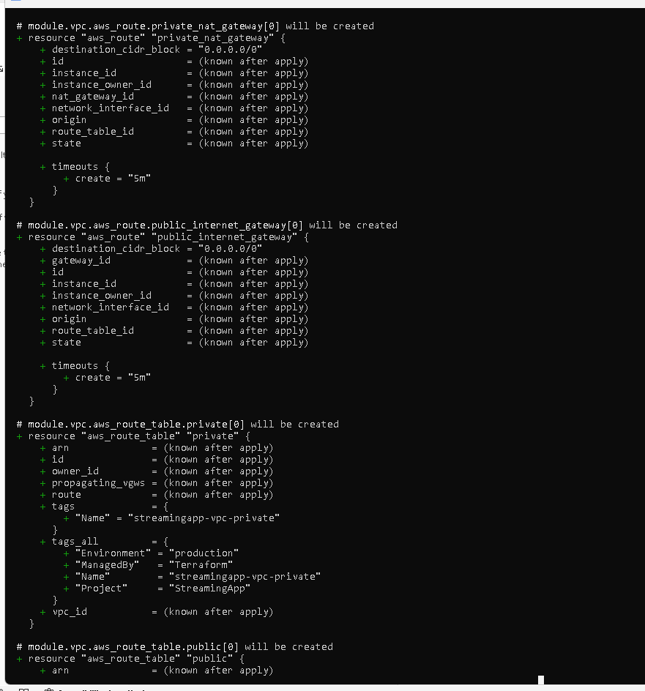
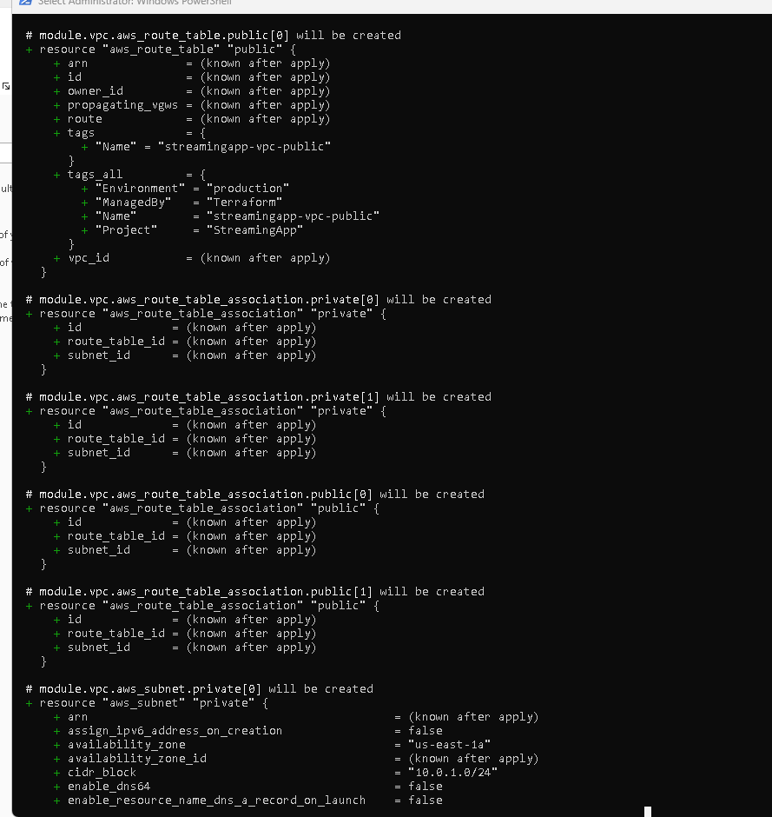
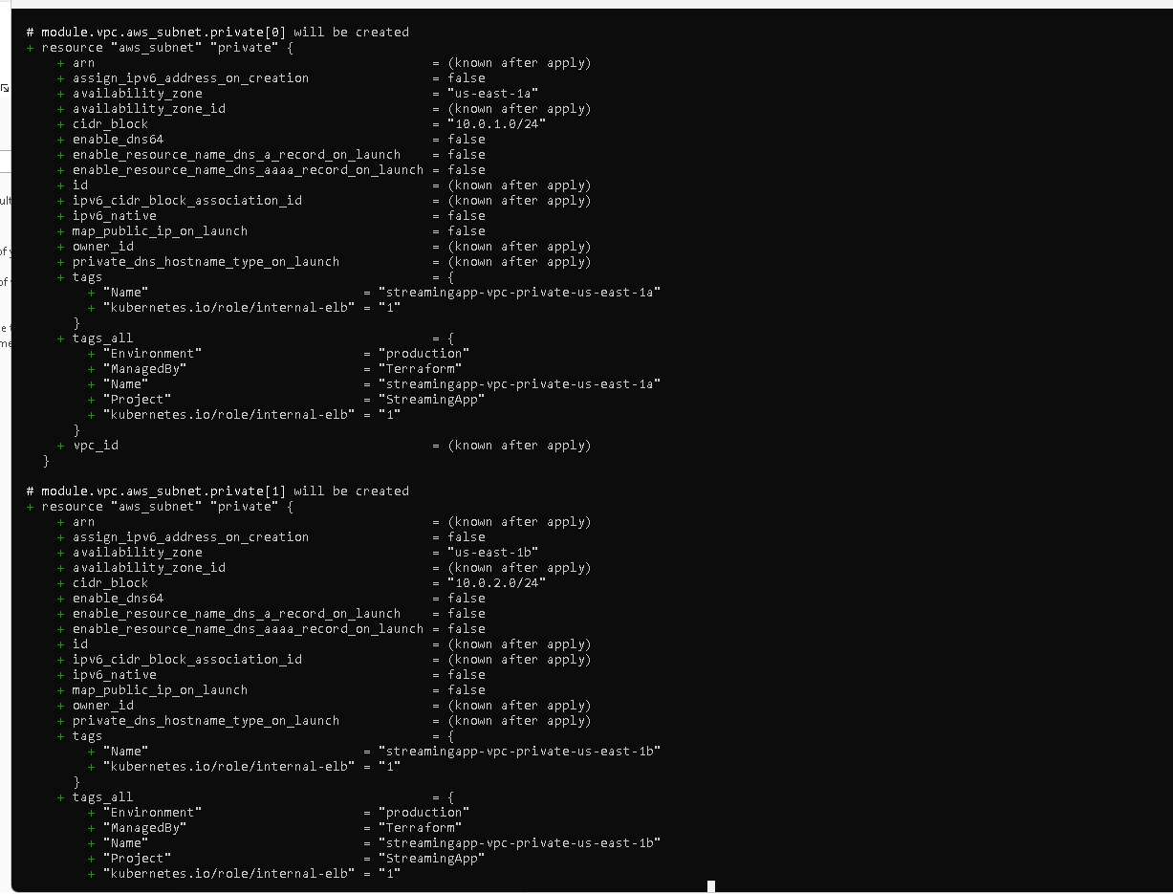
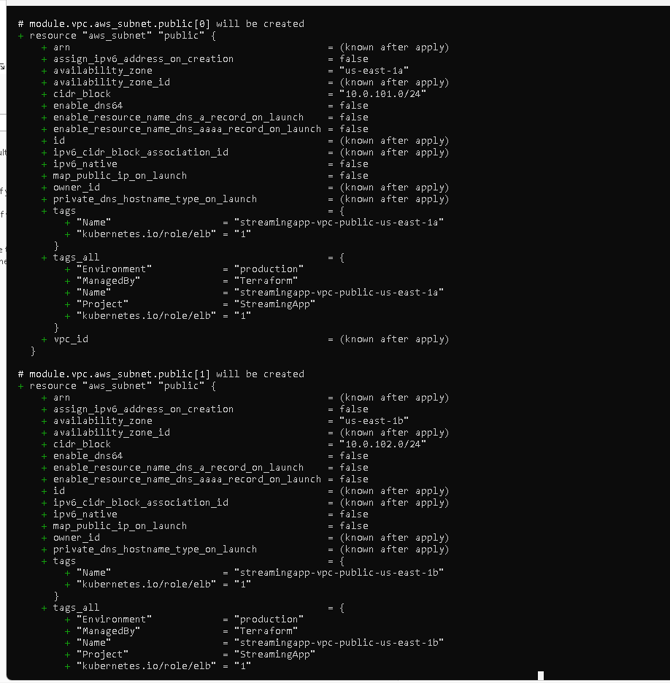
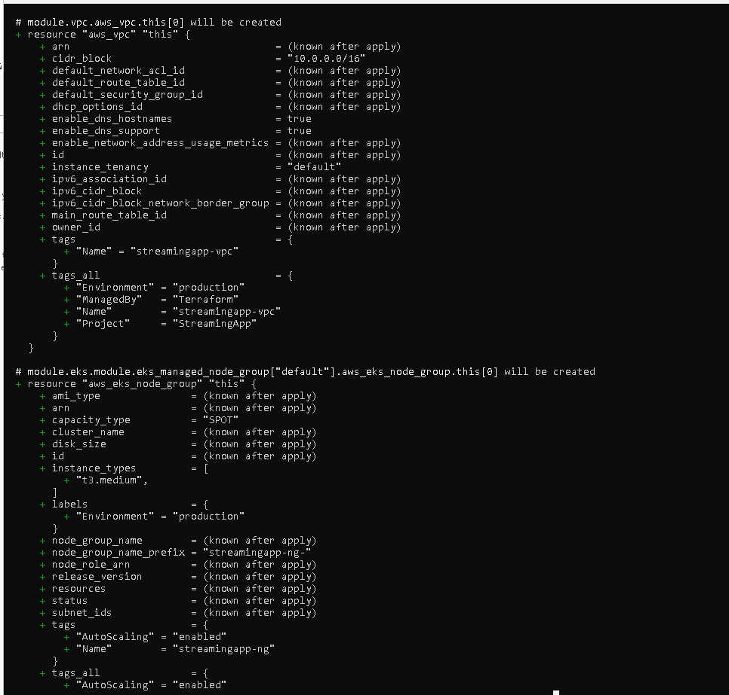
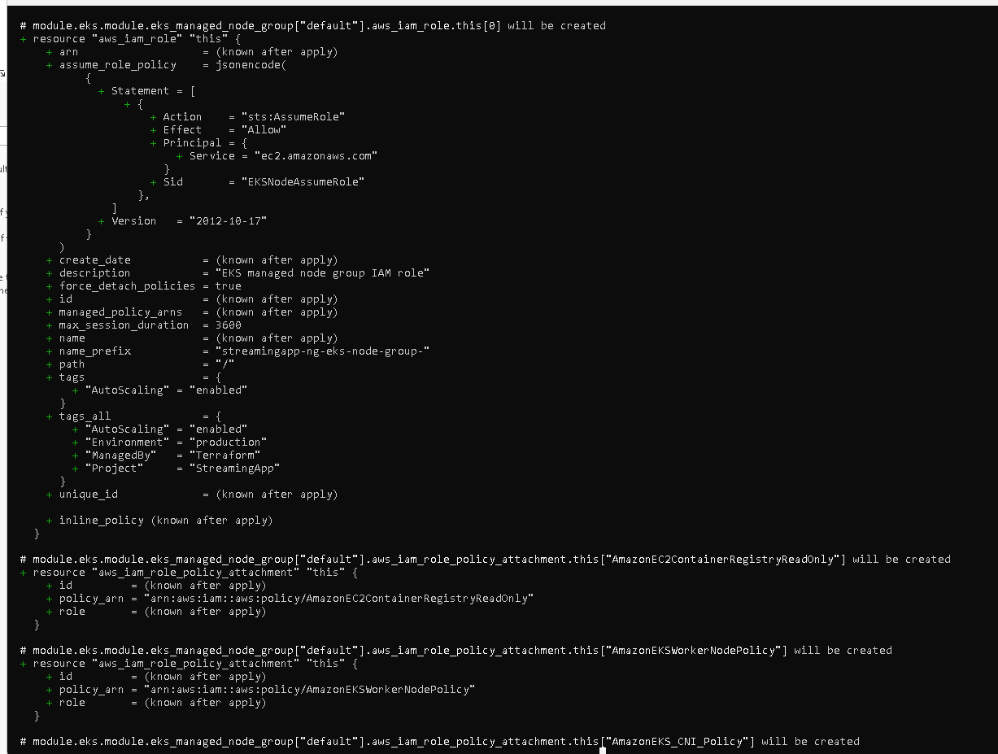
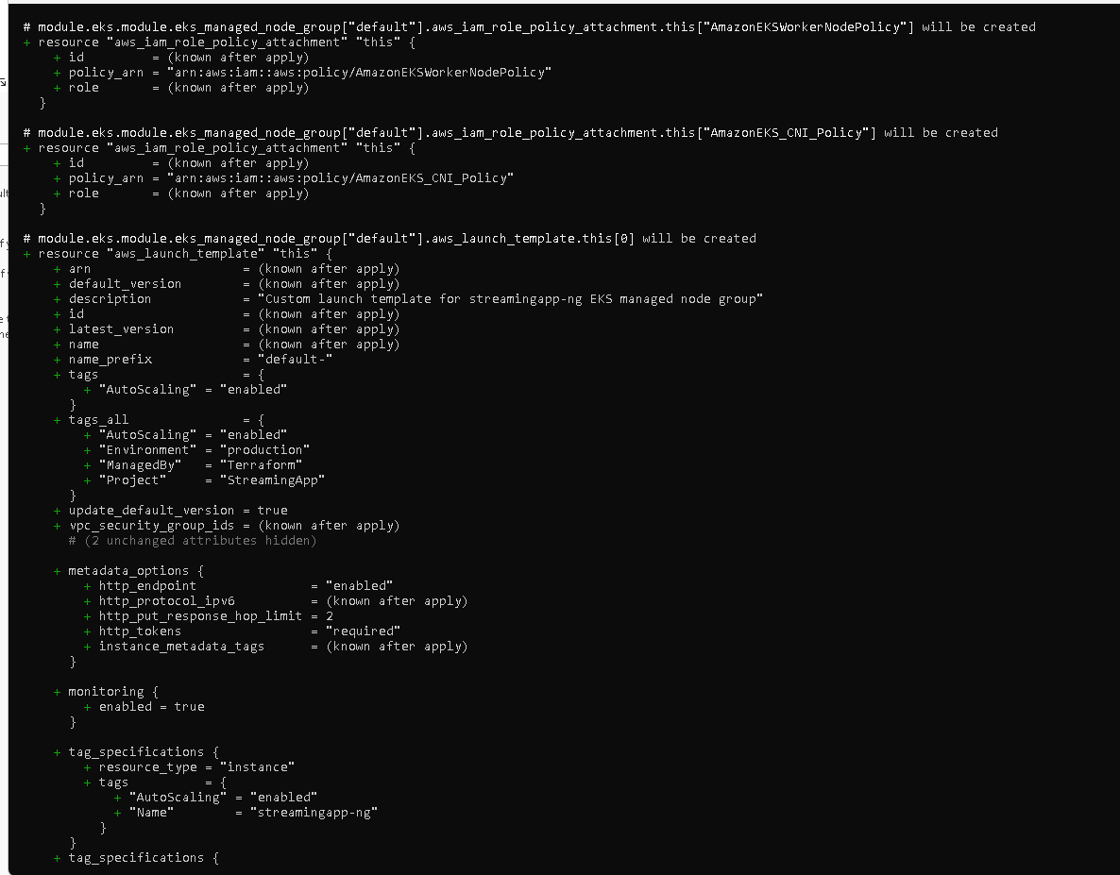
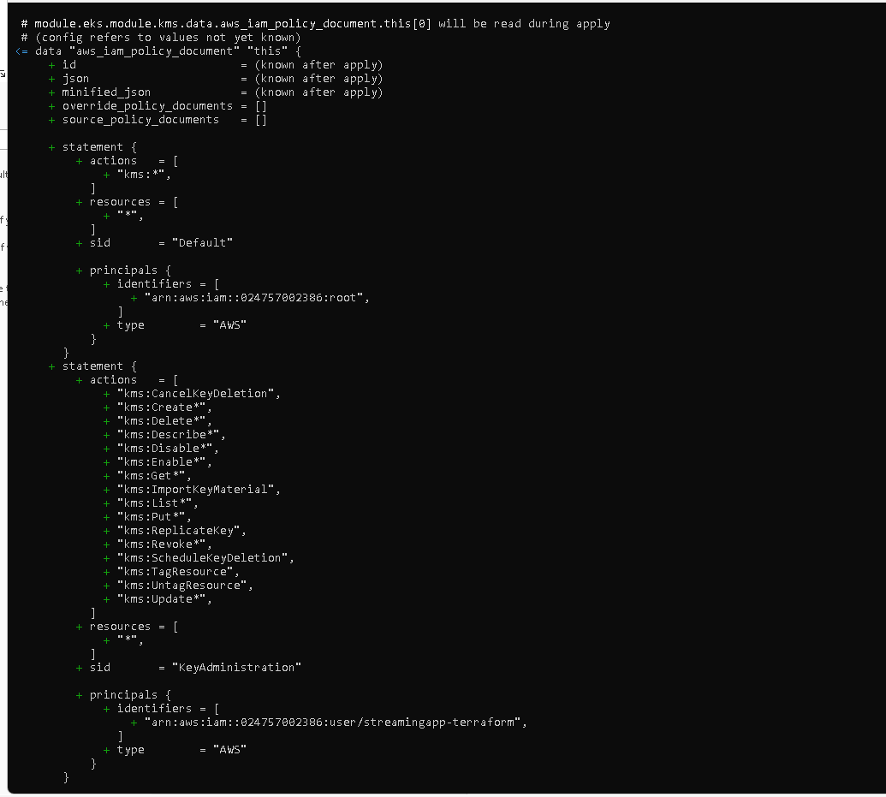
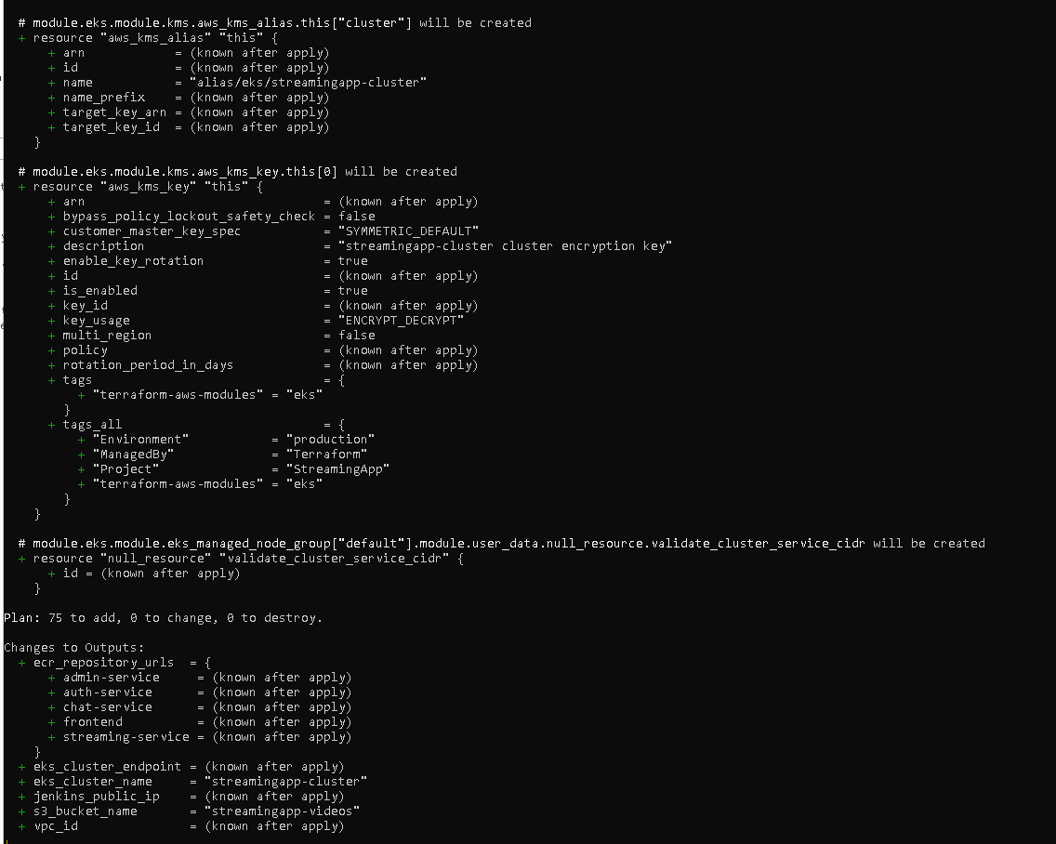
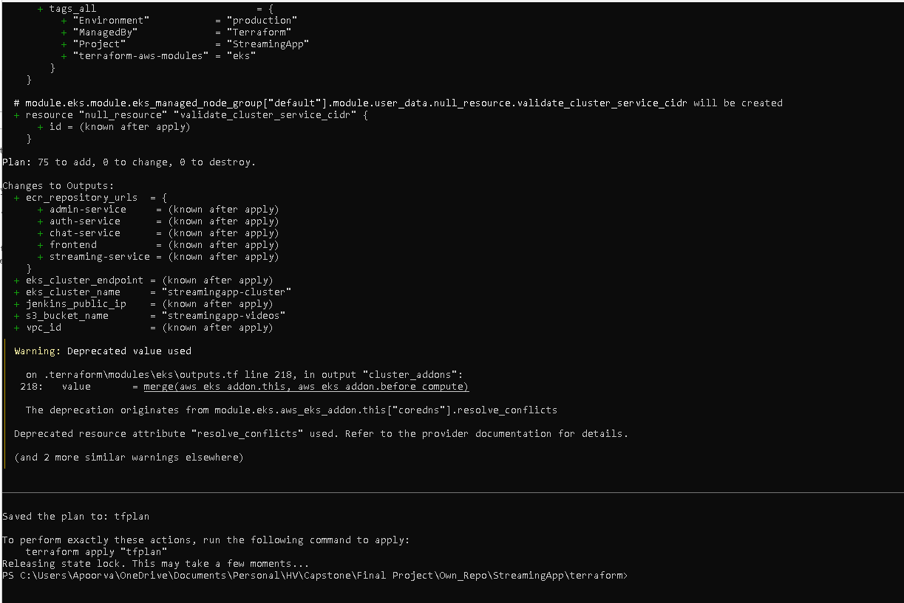
Terraform apply:
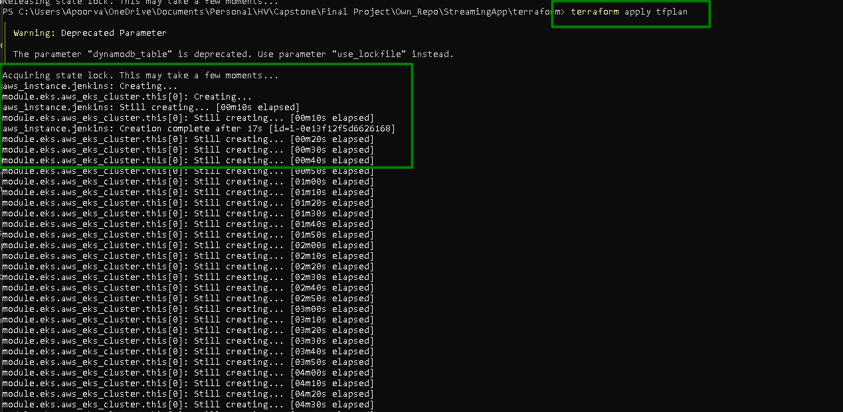
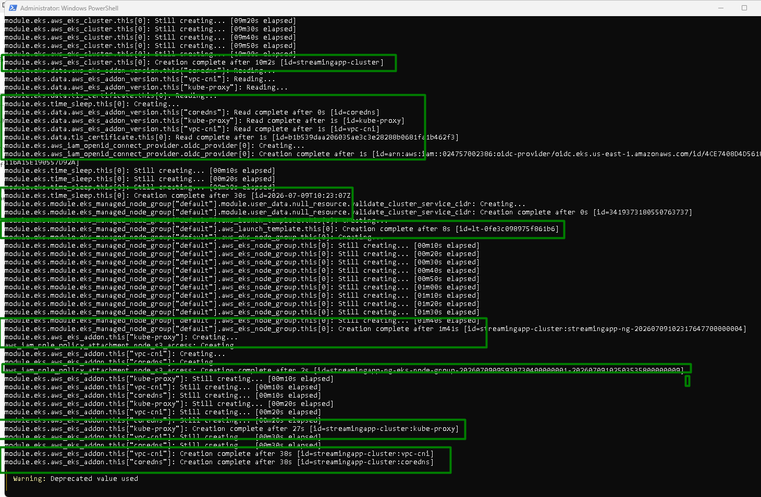
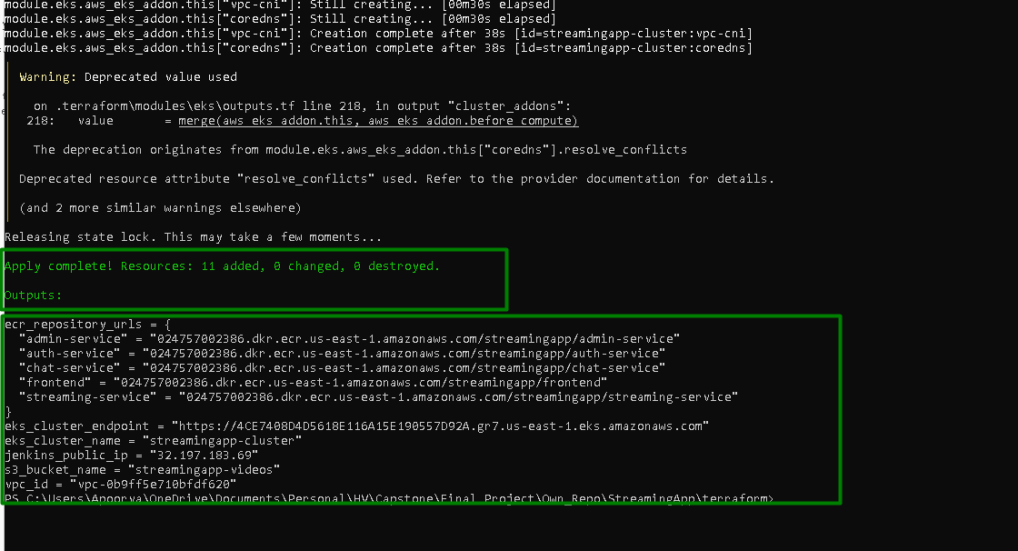

Confirm Jenkins EC2 is reachable:
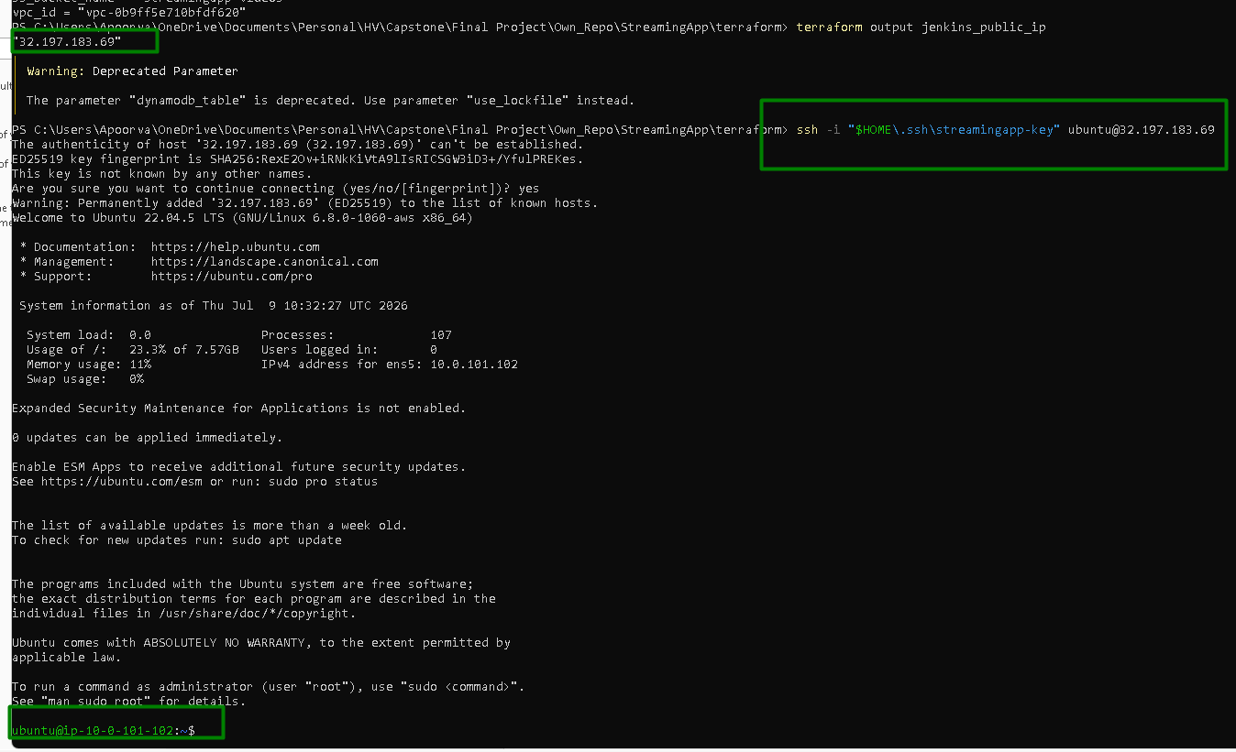

All the resources are created on AWS:

VPC is created
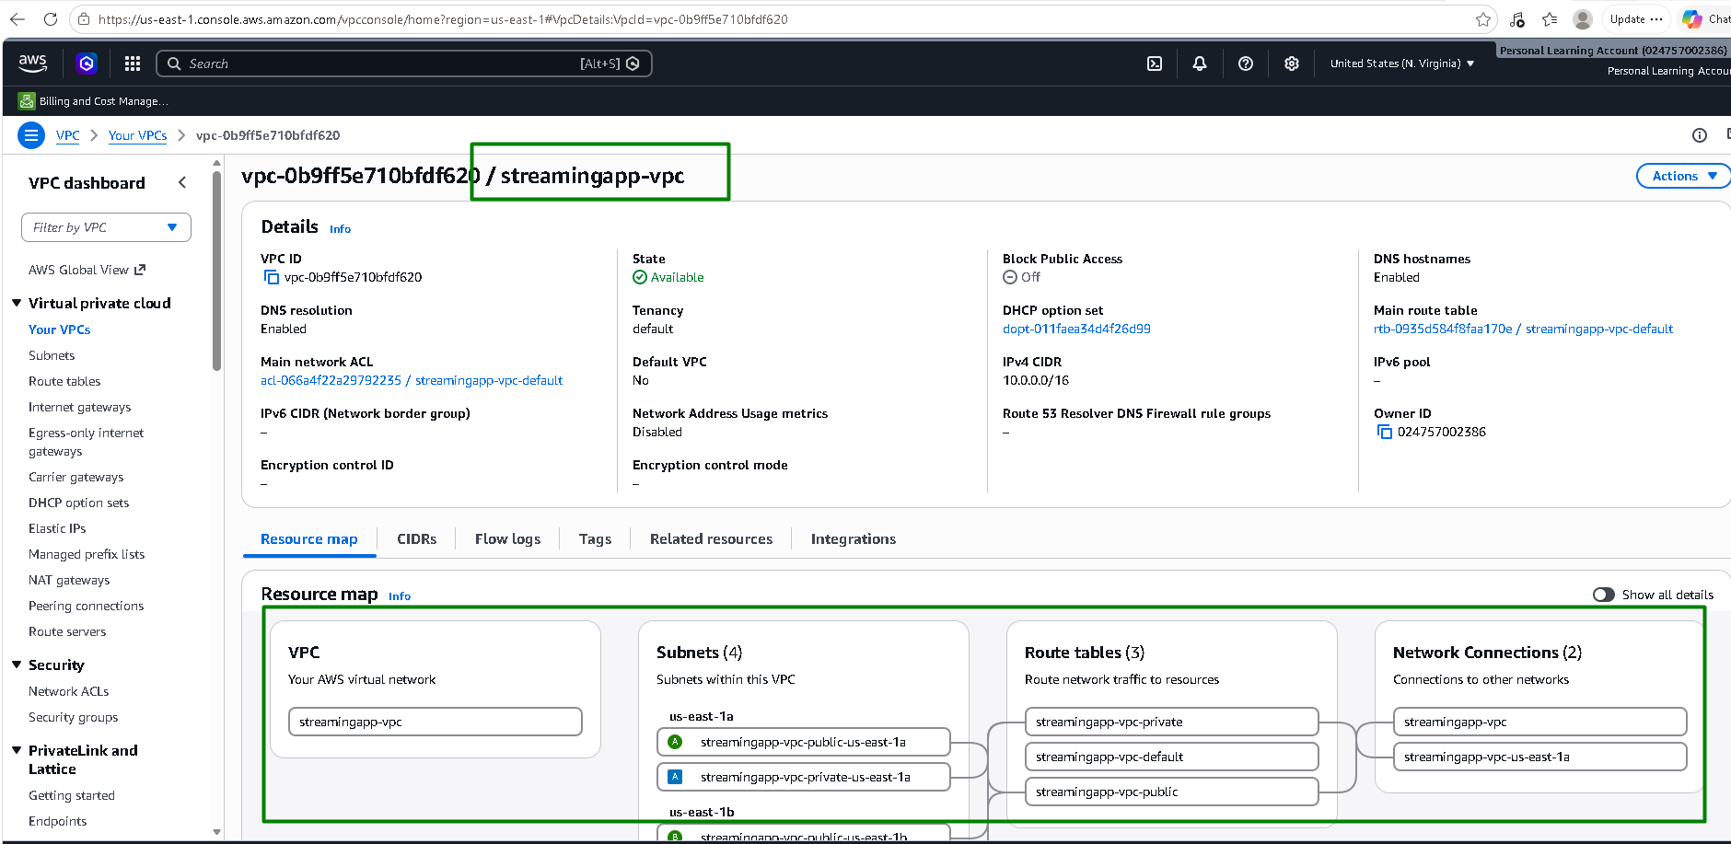
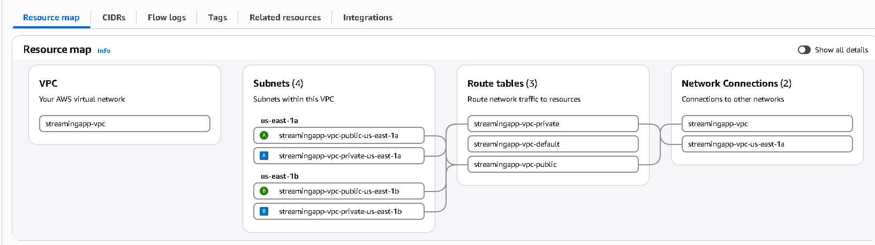
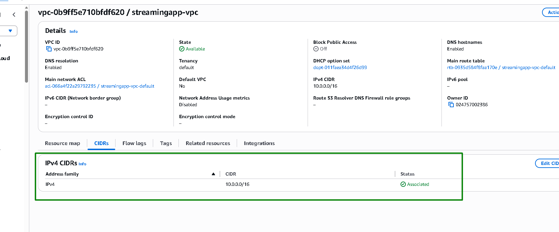

2 public and 2 private subnets are created:
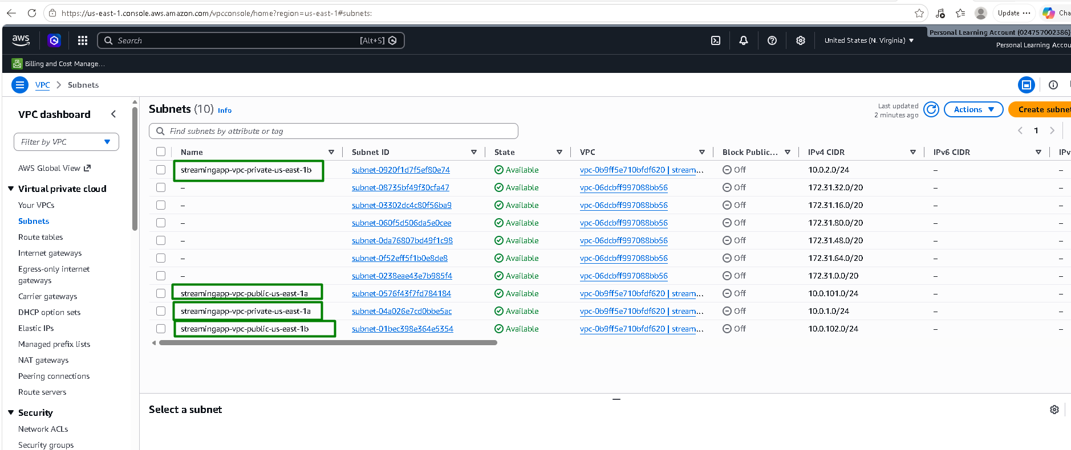

1 NAT Gateway:
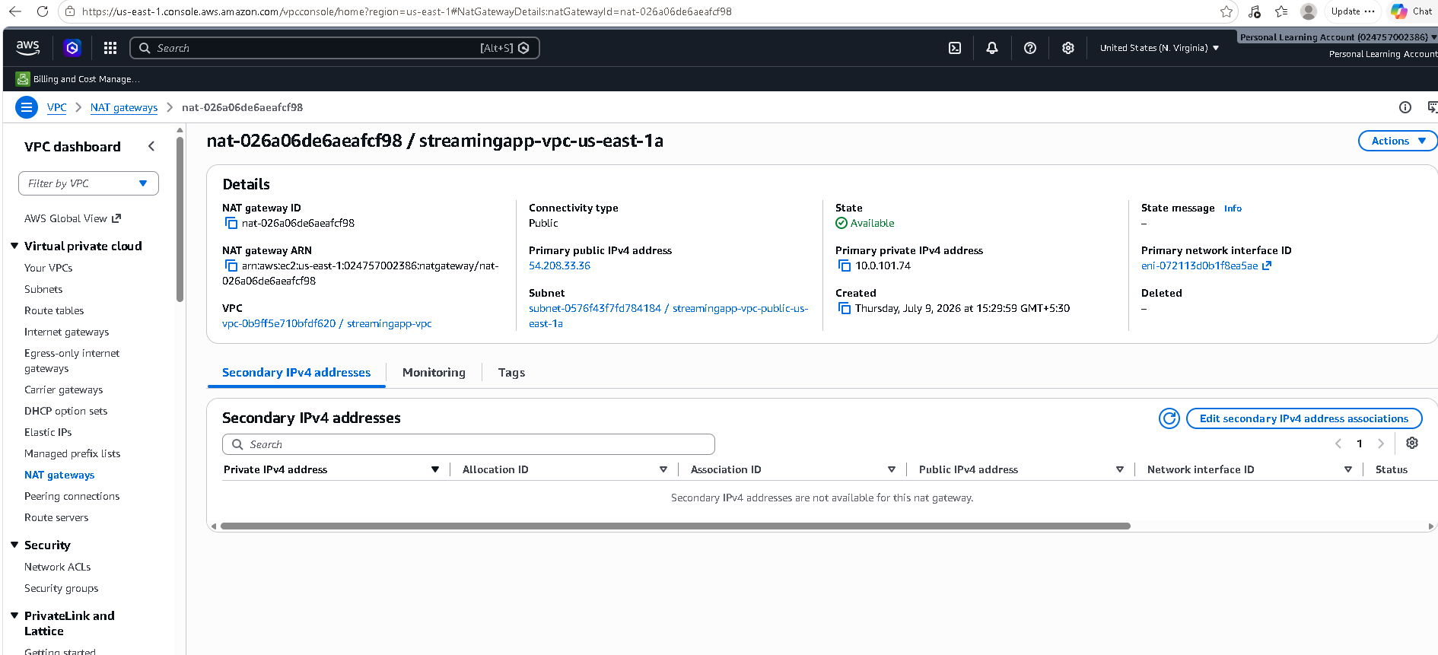

1 Internet Gateway:
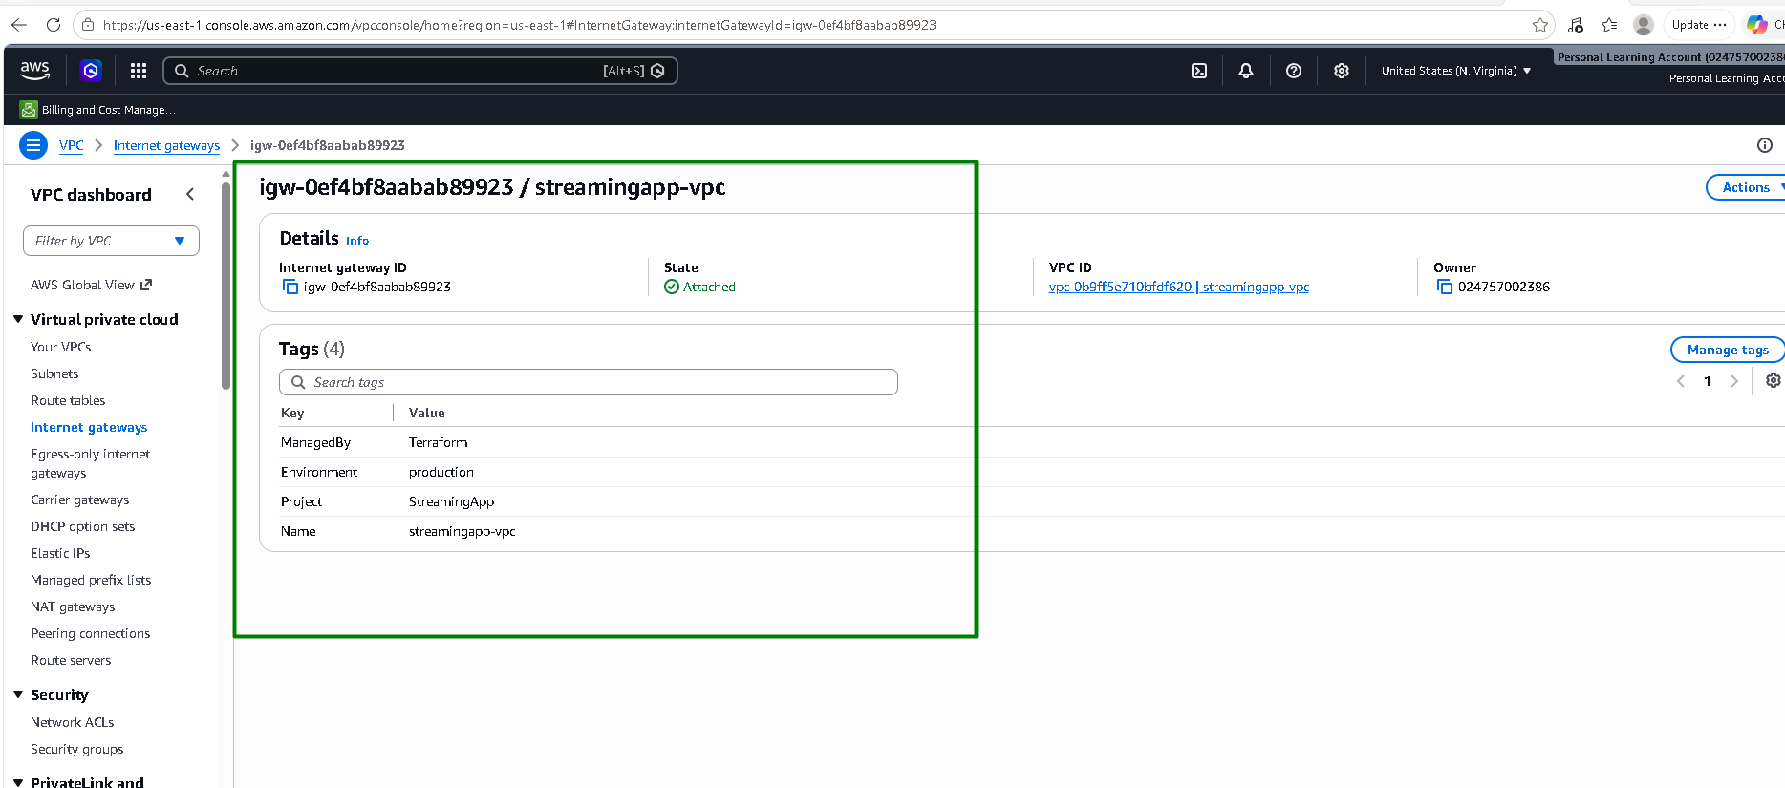

A public RT routing:
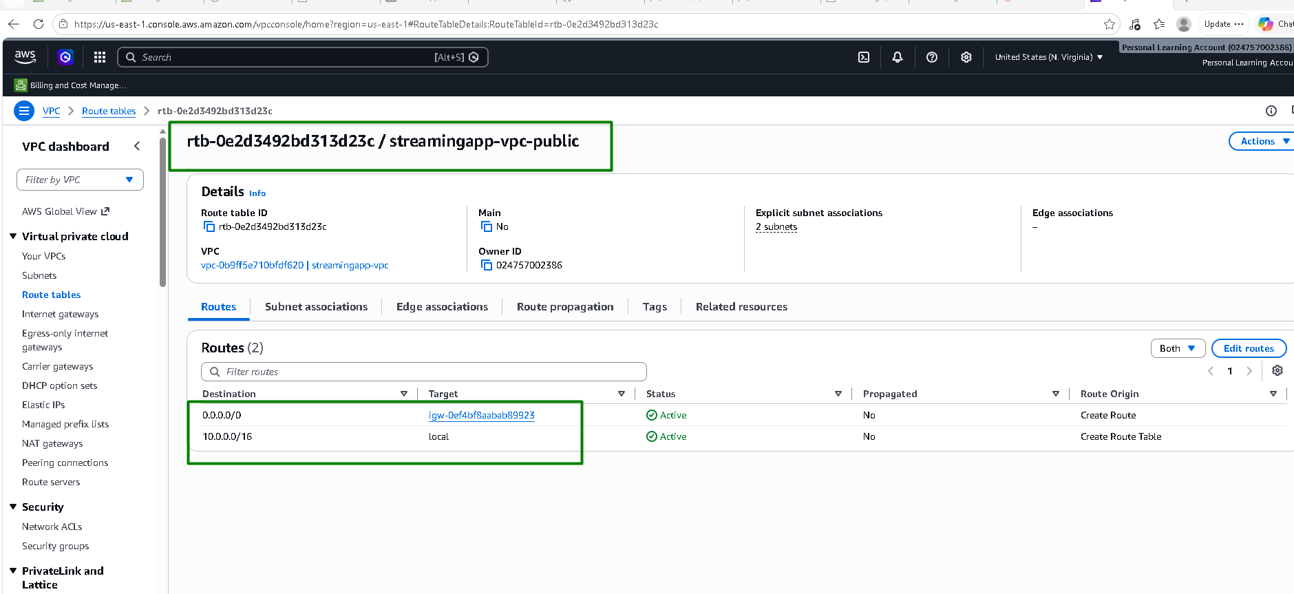

A private RT routing:
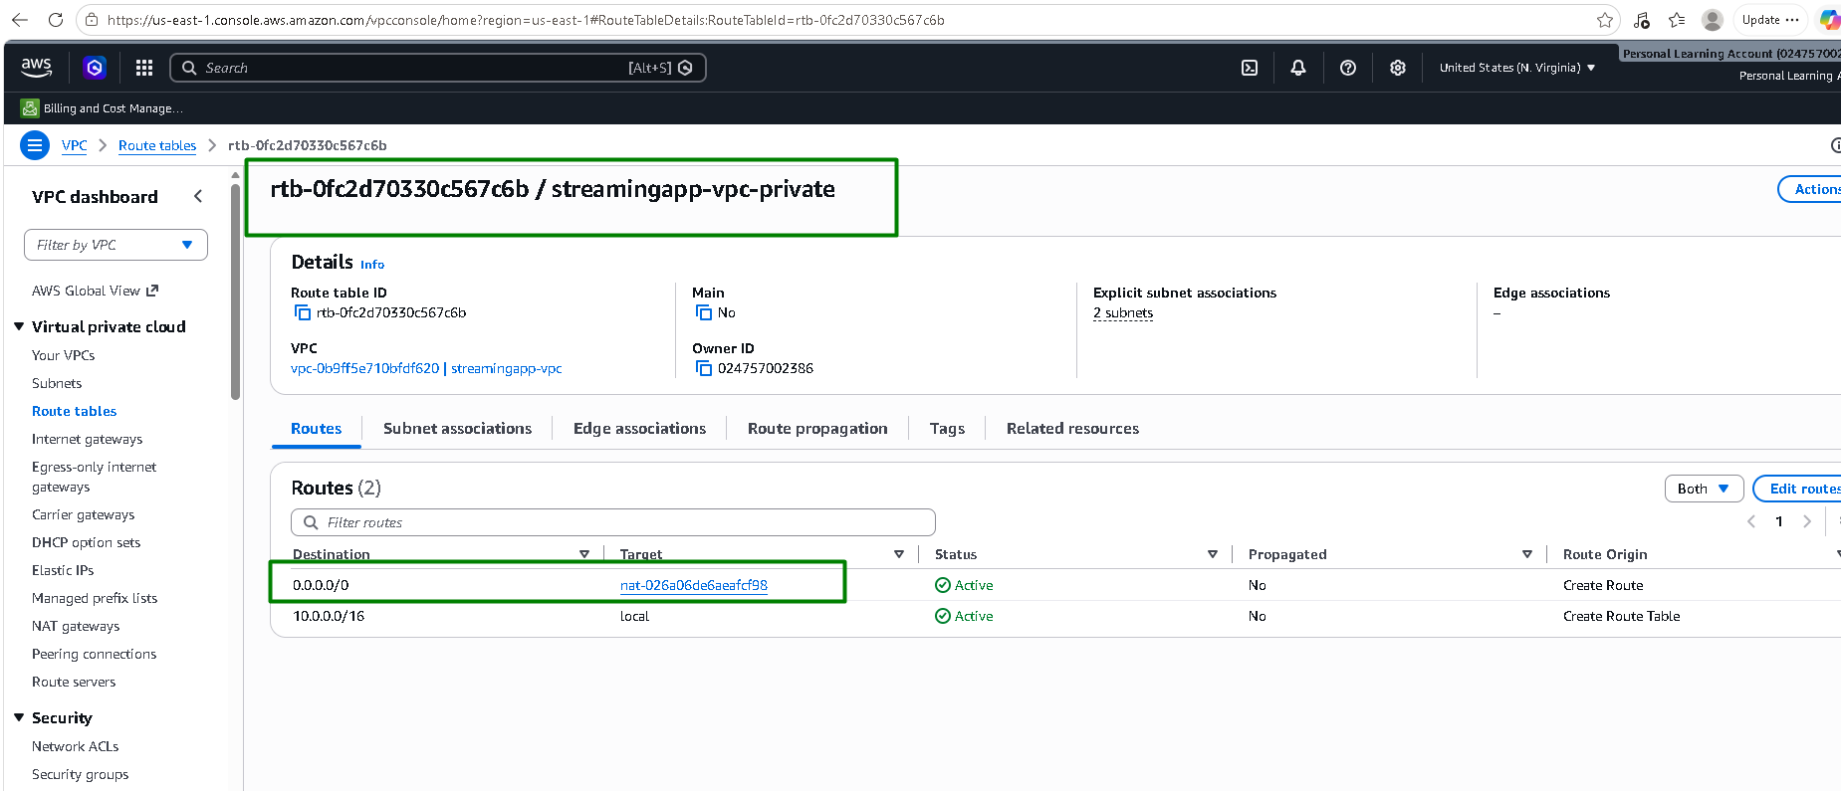

Streamingapp Cluster is created with node group and nodes:
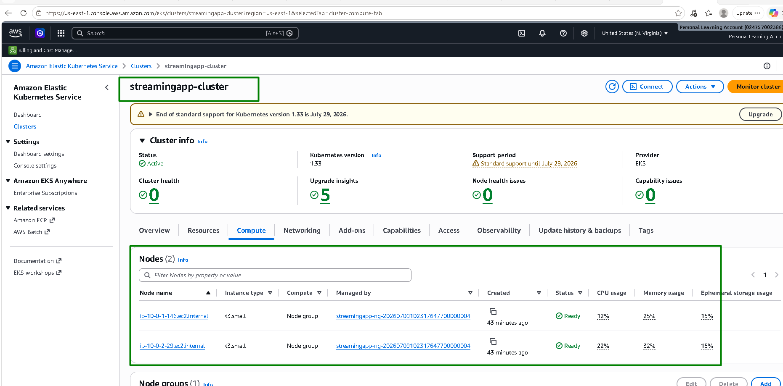
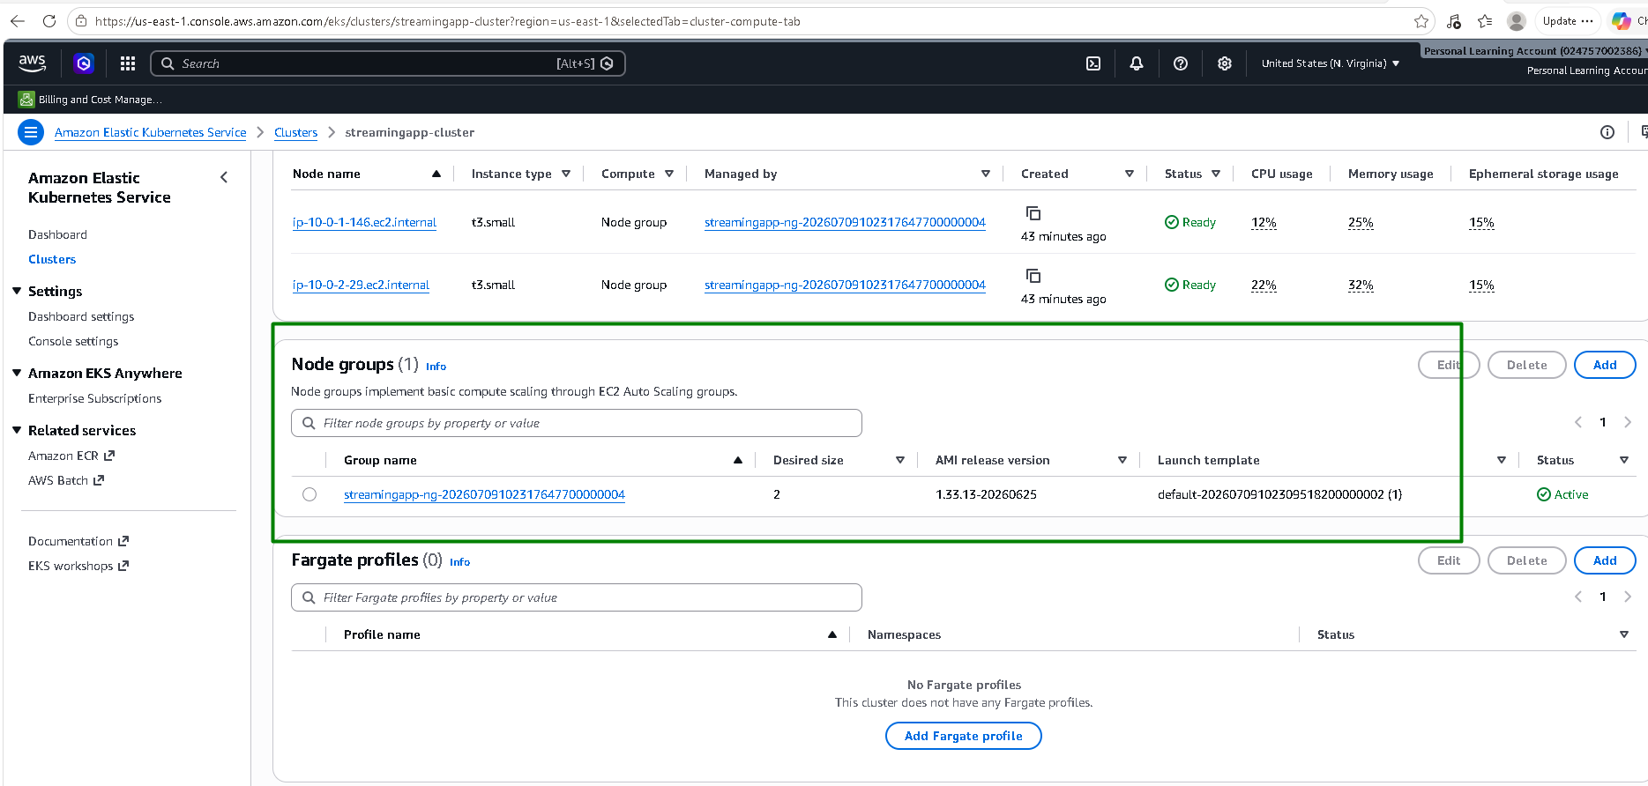

EC2:
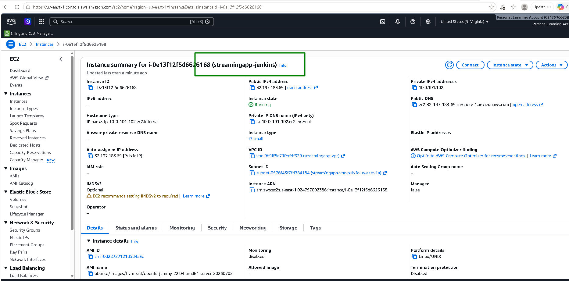
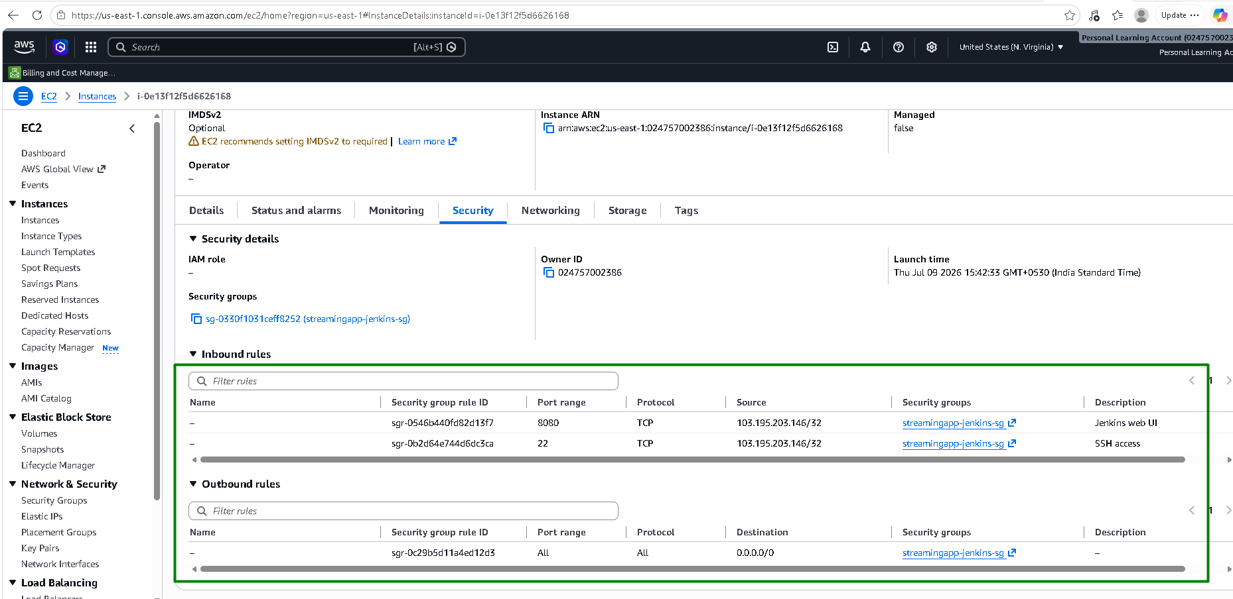

ECR:
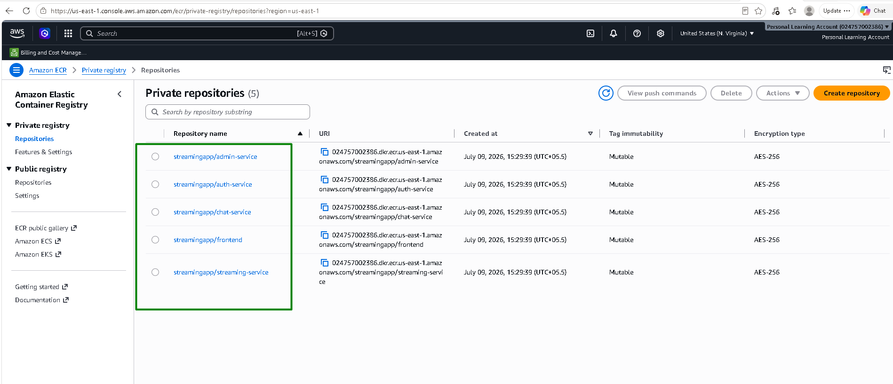

S3:
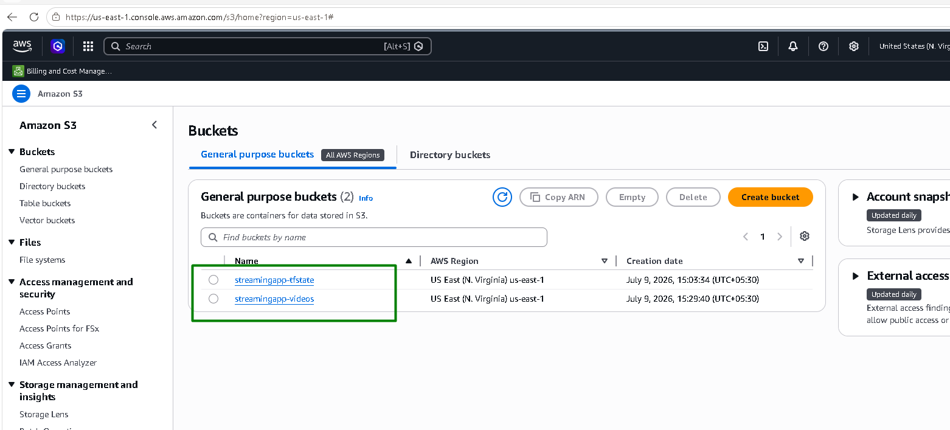

IAM roles:
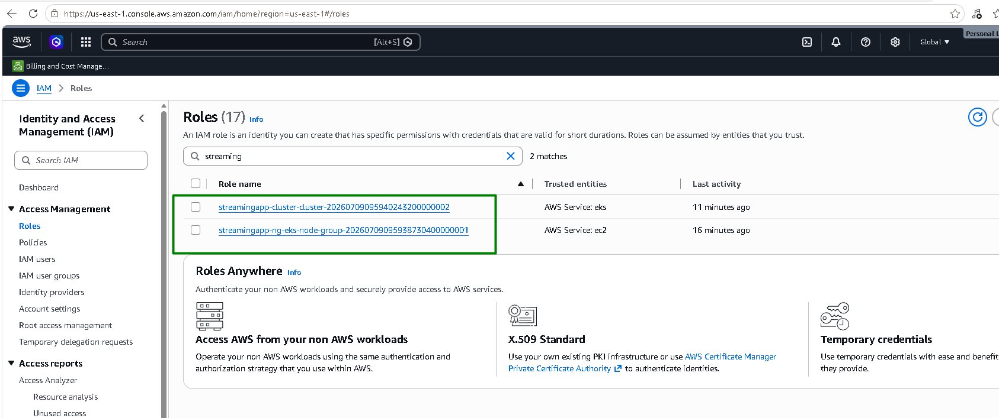
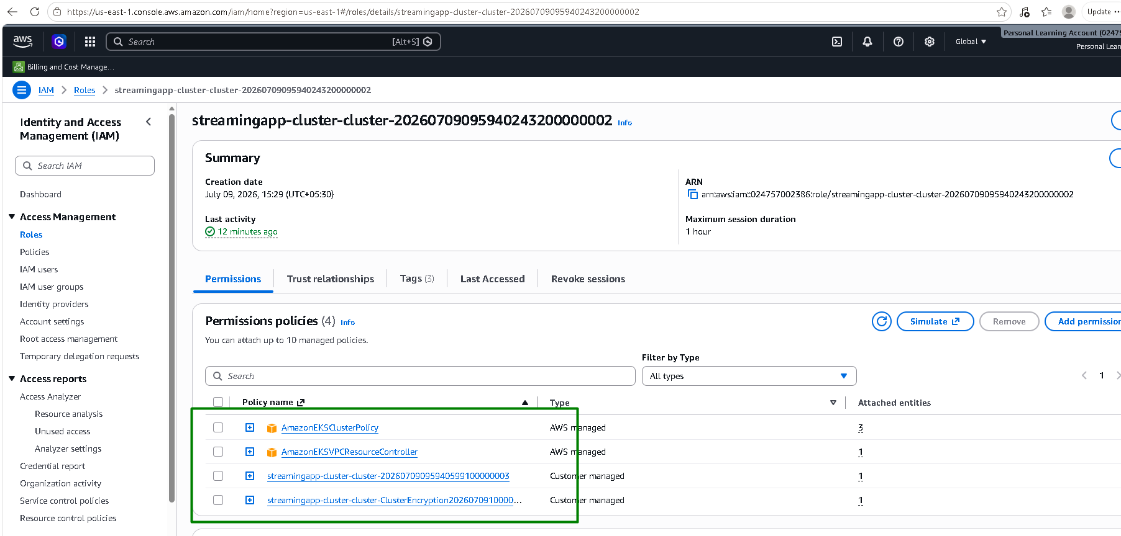
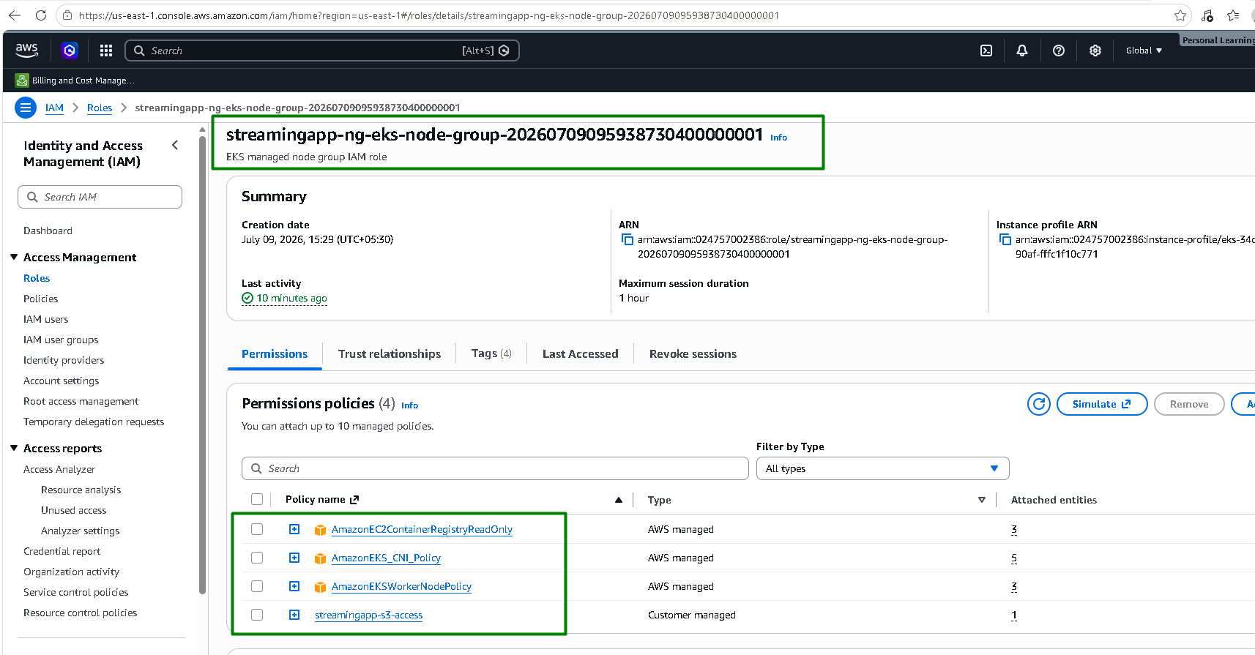

Dynamo DB:
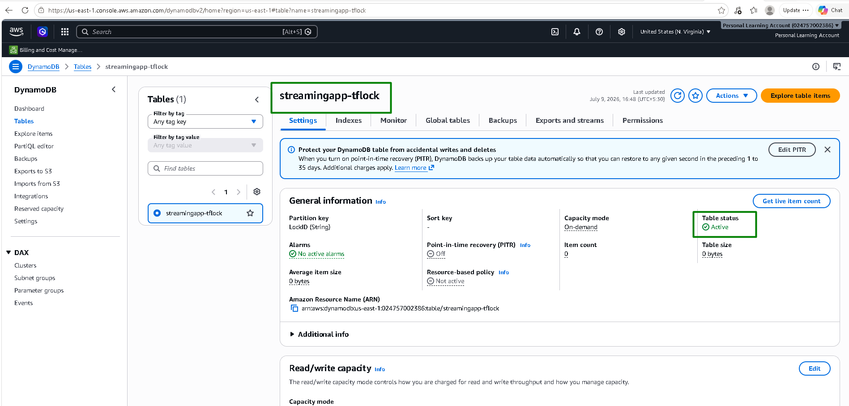

KMS:
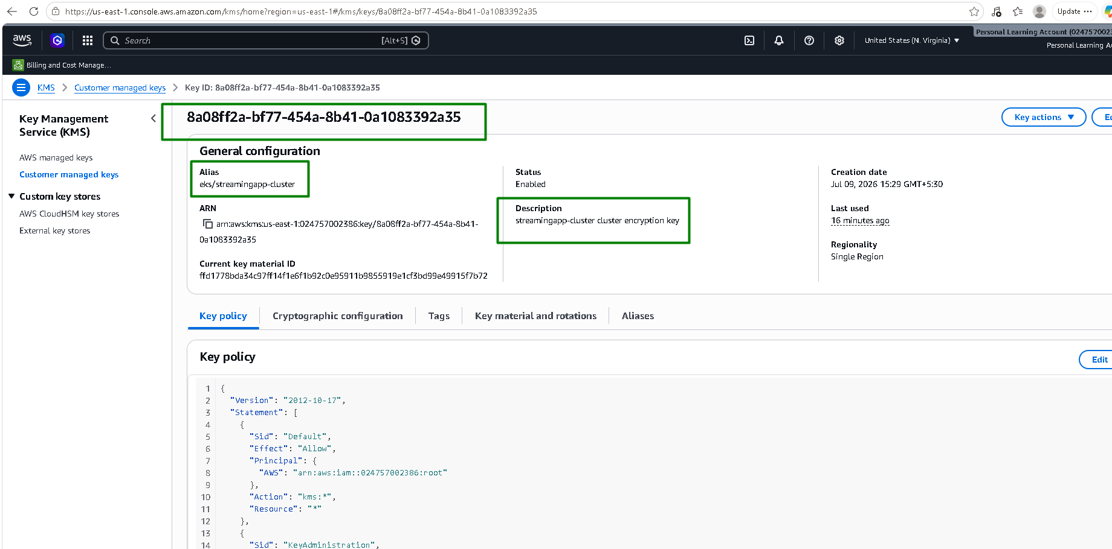

Cloudwatch:
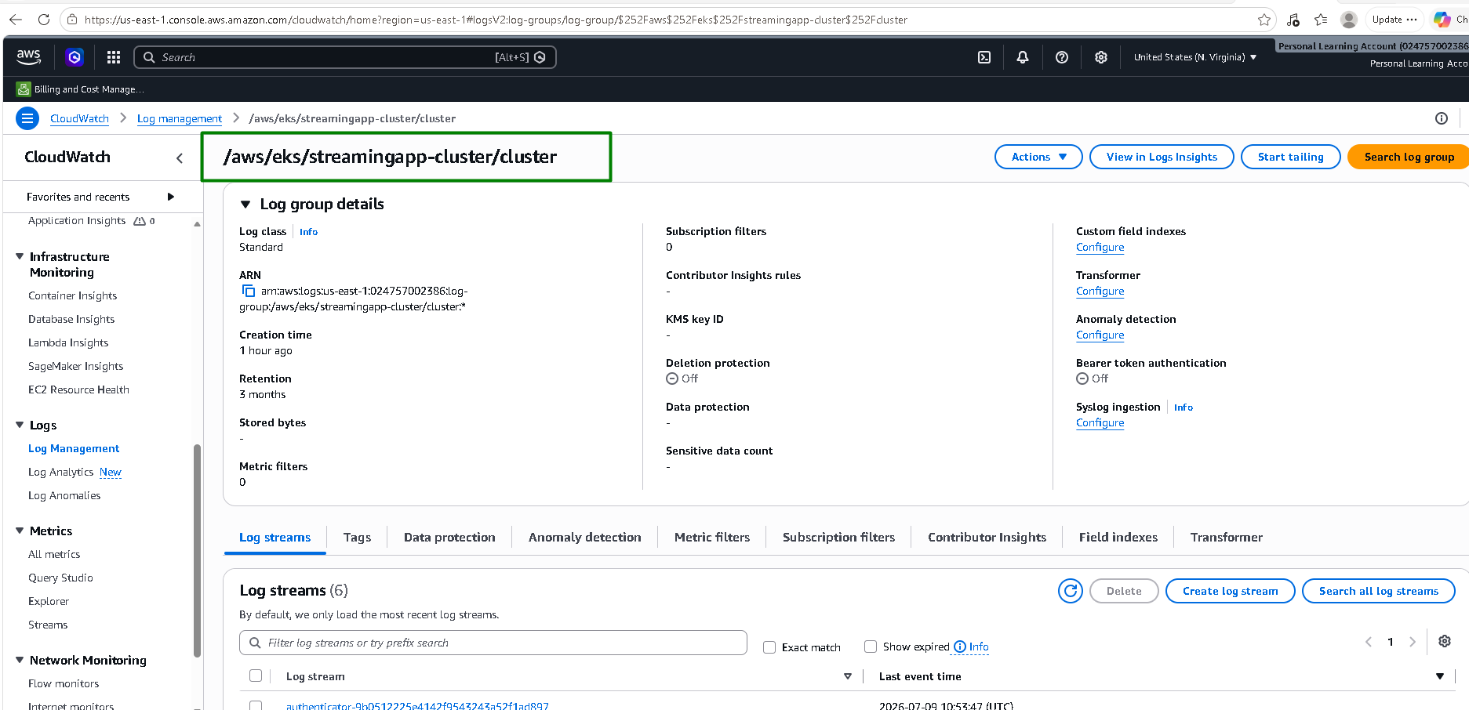
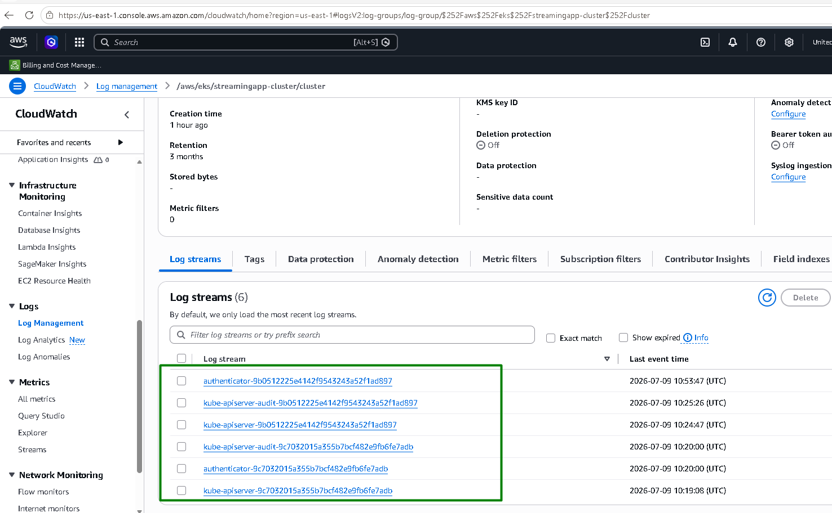

Ansible — Jenkins EC2 fully configured via the dynamic AWS inventory, real SSH, real playbook run, zero failures
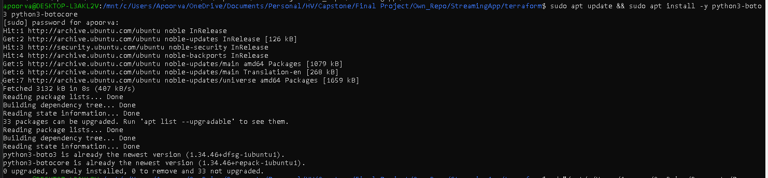
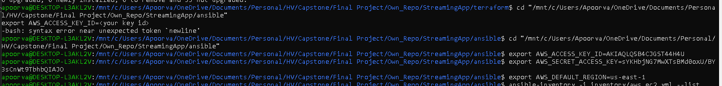
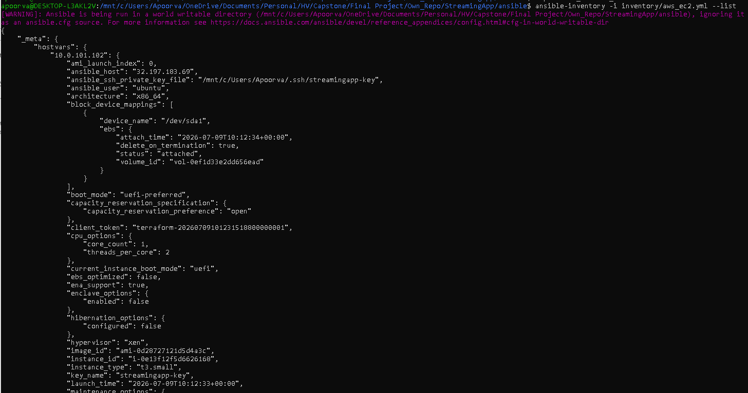
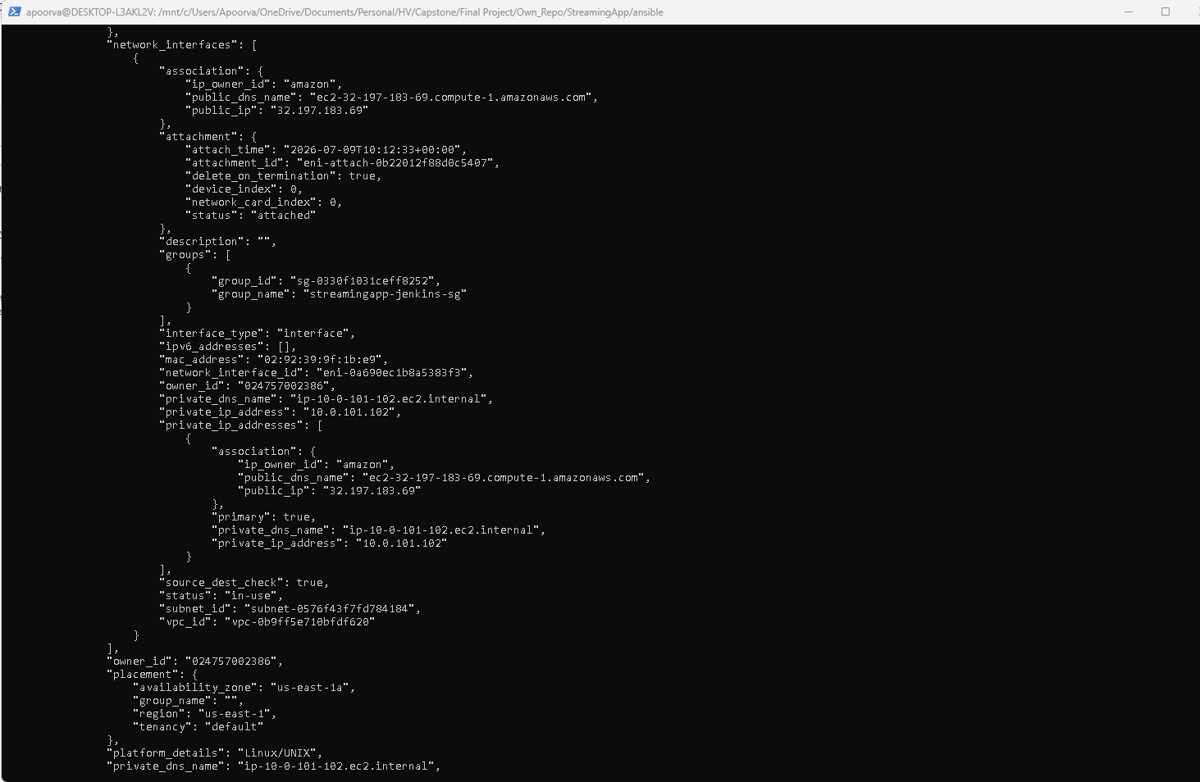
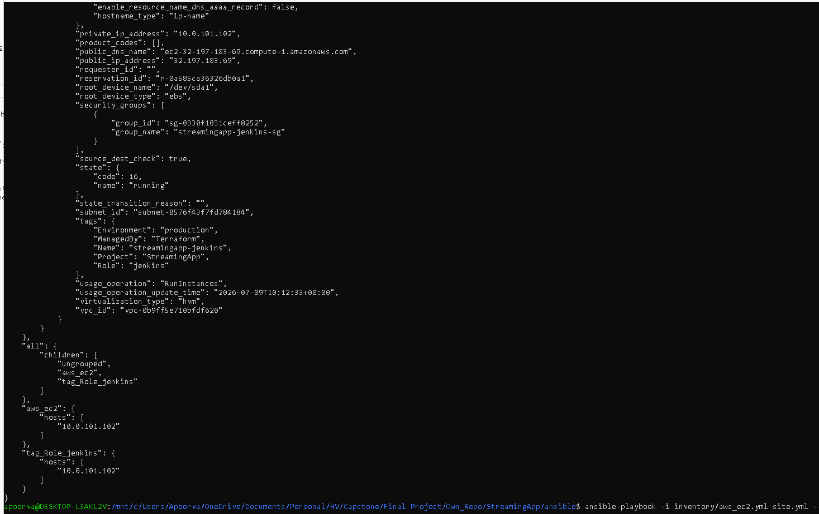
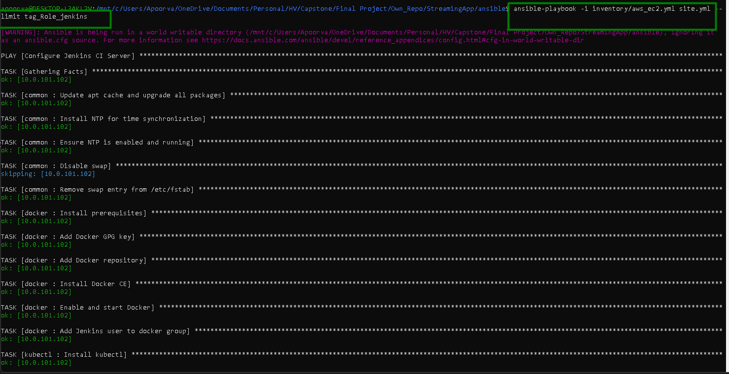
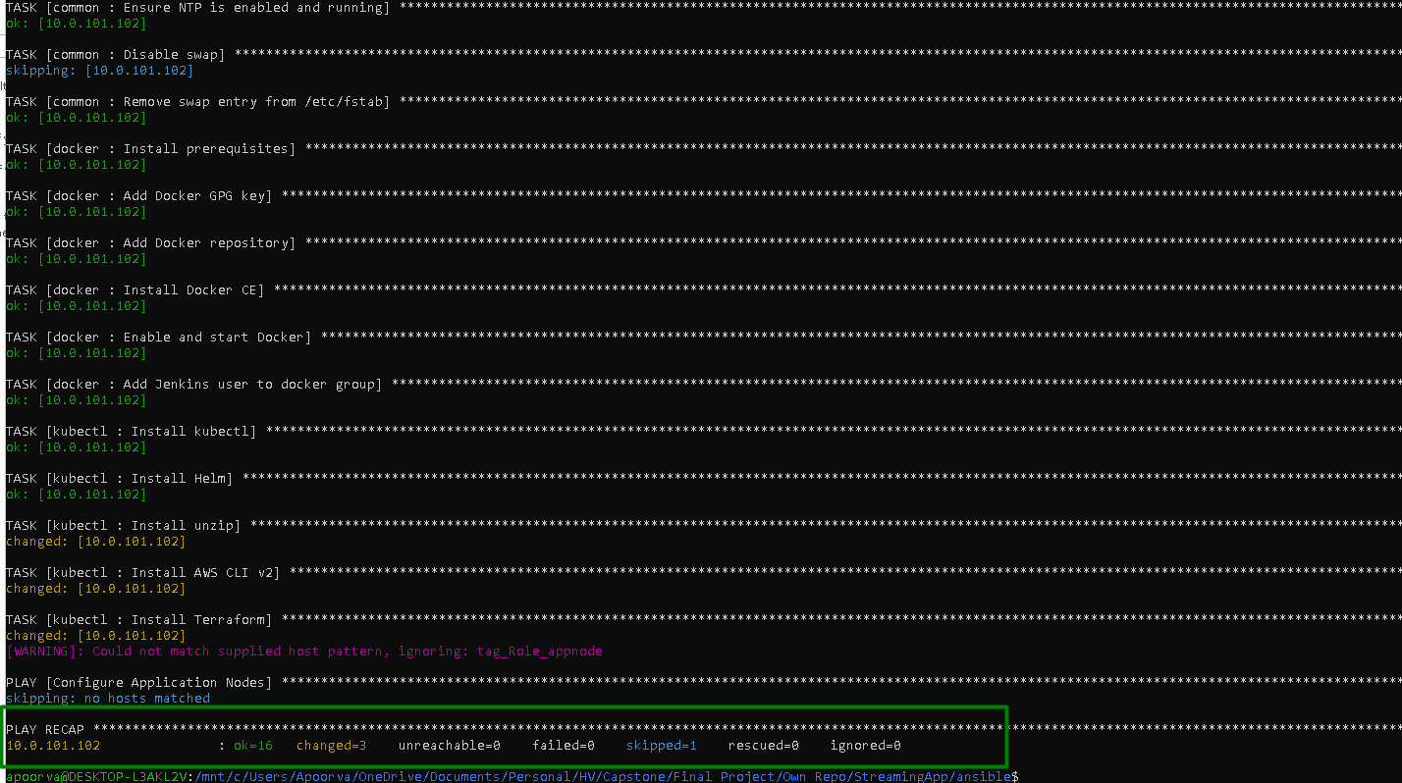

That's everything through Ansible confirmed working on actual AWS infrastructure, not just locally.

Next Steps: building/pushing real images to ECR, deploying the app to EKS, and eventually the ALB Ingress

